GUIDEBOOK ON SIGNAL CONTROL STRATEGIES FOR PEDESTRIANS

By
Sirisha Kothuri, Ph.D.
Andrew Kading
Portland State University

Edward Smaglik, Ph.D., P.E.
Christopher Sobie, EIT
Northern Arizona University
for

National Institute for Transportation and Communities (NITC)
P.O. Box 751
Portland, OR 97207

INTRODUCTION
Wide ranging benefits associated with walking such as improvements in physical health, and, reduction of congestion and emissions have led to its increased popularity as a sustainable transportation mode. As a result, many cities are desirous of promoting policies that encourage walking and operating the transportation system to include the needs of pedestrians.
Most of these walking trips take place in urban areas and involve street crossings, which may be at intersection or mid-block. Legacy signal timing practices at signalized intersections have prioritized vehicular movements, which sometimes can lead to large and unnecessary delays for pedestrians. Safety vs. efficiency is perhaps the most well-known trade-off in transportation engineering. Limited pedestrian control strategies that have been adopted so far – leading pedestrian intervals and Barnes dance have focused largely on safety. Efficiency related control strategies – free operation, shorter cycle lengths and actuated coordinated have been rarely used with a focus on improving pedestrian operations.
The purpose of this guidebook is to describe the available safety and efficiency based control strategies for pedestrians, along with their potential impacts and any site and operational characteristics that could influence the choice of strategy. This guidebook is intended to help practitioners by presenting them with a toolbox of pedestrian signal control strategies, which they could use to guide their choice of treatment depending on specific characteristics of their site.
The remainder of this guidebook is laid out as follows. A description of the safety based strategies – Leading pedestrian intervals and Barnes Dance follows next. Efficiency based strategies – Free operation, Short cycle lengths, actuated coordination, pedestrian priority algorithm and permissive length reduction are described next. A comparative analysis follows at the end and the guidebook concludes with recommendations.

PEDESTRIAN SIGNAL CONTROL STRATEGIES
The purpose of signal timing at an intersection is to separate the conflicting movements in time. A properly designed and timed signal is expected to provide a range of benefits such as maximizing flow at an intersection, reducing severity and frequency of certain types of crashes, allow orderly and efficient movement of people and provide appropriate levels of accessibility for pedestrians and side street traffic (Koonce et al., 2008). The prioritization of modes within the signal timing process depends on regional goals and policies.
Pedestrians have typically not been considered in this prioritization process and have been accommodated in a manner that causes the least amount of disruption to the flow of vehicular traffic. At signalized intersections, pedestrians are typically served using concurrent signal phasing, which allows them to cross the street along with the parallel vehicle movements. In this phasing, turning vehicles are expected to yield to pedestrians. However, at certain intersections safety strategies such as leading pedestrian intervals and the Barnes dance have been utilized to increase pedestrian safety. Efficiency based strategies such as free operation, reducing cycle lengths, actuated coordination and pedestrian priority algorithm reduce pedestrian delay. These are described further below.

Leading Pedestrian Intervals
Leading Pedestrian Interval (LPI) refers to a signal control strategy by which pedestrians are provided with an exclusive walk signal for a few seconds prior to the onset of the concurrent vehicular green indication. In a typical situation a pedestrian Walk signal illuminates for several seconds before the corresponding vehicle signal, thereby providing the pedestrians with greater visibility by allowing them to enter the intersection before the turning vehicles. After the first few seconds, the vehicular green indication for the parallel movement is served and the operation is similar to concurrent timing. Figure 1 shows the ring barrier diagram, where pedestrian phases 2 and 6 have a LPI.
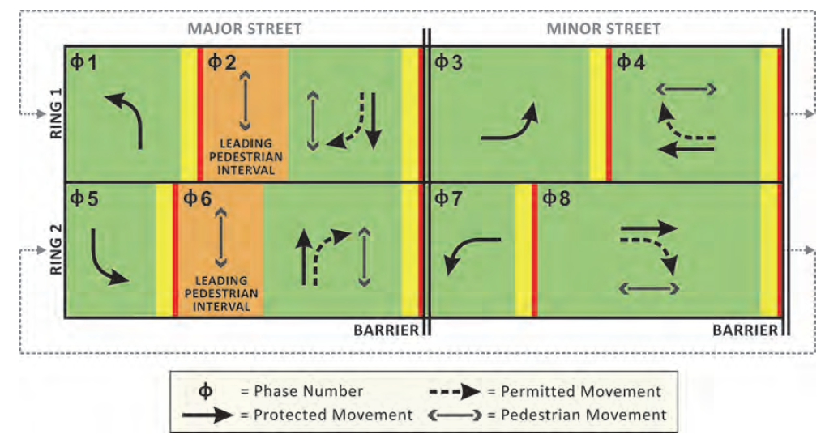
Figure 1 Ring Diagram for Leading Pedestrian Intervals
(Source: Urbanik et al., 2015)

Literature Review
Many studies have evaluated the safety impacts of LPIs by studying before and after crash data at treatment and control intersections. King studied the crash rates at 26 treatment locations in New York City with LPIs and also at control locations without LPIs. Analysis of the crash data showed significant reductions in motor vehicle and pedestrian crashes (King, 1999). Hubbard et al. estimated the percent of compromised pedestrian crossings at 13 intersections in an effort to quantify pedestrian service (Hubbard et al., 2007). A crossing was defined as compromised if a pedestrian was forced to change their path or speed due to a turning vehicle (Hubbard et al., 2007). Hubbard et al. recommended that if the percentage of compromised crossings exceeded 15%, a LPI may be appropriate (Hubbard et al., 2007). In another study, Hubbard et al. compared the speed and headways of vehicles turning right on a red light vs. a green light at intersections and found that as expected mean speeds of vehicles turning right on red were lower and headways were higher than for vehicles turning right on green (Hubbard et al., 2009). They suggest that these factors must be taken into consideration when implementing an LPI (Hubbard et al., 2009). Van Houten et al. studied the implementation of 3-s LPIs at three intersections by examining conflicts (Van Houten et al., 2000). Their results revealed that conflicts between pedestrians and turning vehicles as well as occurrences of pedestrians yielding the right-of-way to turning vehicles were reduced (Van Houten et al., 2000). Using a before-after study design and data from 10 treatment intersections where the LPIs were implemented and 14 control intersections without LPIs, Fayish and Gross studied the safety effectiveness and found 58% reduction in pedestrian-vehicle crashes at treatment locations (Fayish and Gross, 2000). Additionally, a simple economic analysis was conducted to assess the cost effectiveness of implementing an LPI (Fayish and Gross, 2000). Using a cost benefit analysis, they showed that LPI implementation was economically beneficial (Fayish and Gross, 2000). However, only crash costs were included in the analysis and delay costs were excluded. Guidelines on assessing the suitability of candidate locations for LPI implementation have been scarce. Sainenejad and Lo proposed a suitability assessment worksheet for LPIs based on a number of factors (Sainenejad and Lo, 2015).

Impacts
The results from a review of the literature showed that significant reductions in pedestrian-vehicle crashes at intersections with LPI implementation. Efficiency impacts have been less studied. Our research findings on efficiency impacts of an LPI showed that overall delays increase at an intersection due to the implementation of an LPI. This is due to the lost time for vehicles. The actual magnitude of increase depends on a number of factors such as the length of the leading pedestrian interval, whether the intersection is in coordination, cycle length and whether the LPI has been implemented for pedestrian phases on the major, minor street or both. As expected, our results showed higher increases in magnitudes of delay, when the LPI was implemented for the major street pedestrian phases.

Implementation
As LPI is primarily a safety strategy, the choice of whether or not to implement it should primarily be based on an assessment of pedestrian safety at the intersection. Examining the crash history, including frequency, severity and types of crashes, can help in the assessment of suitability. Sainenejad and Lo provide a worksheet that can be used to assess if a particular location is a good candidate for implementation (Sainenejad and Lo, 2015). According to Sainenejad and Lo, factors that should be considered include
- Collision rates between pedestrians and turning vehicles,
- Volume of pedestrians,
- School proximity,
- Activity by elderly residents,
- Impacts on vehicle delay,
- Presence of visibility issues
- Intersections with special geometry
Once a candidate location has been chosen, before data pertaining to crash history, observed pedestrian and vehicle behavior should be collected. After implementation, collecting similar data would enable a before-after analysis to be conducted, so that impacts may be analyzed.

Exclusive Pedestrian Phase (Barnes Dance)
An exclusive pedestrian phase (EPP), also known as a Barnes Dance or a Pedestrian Scramble, is a type of phasing in which pedestrians are permitted exclusive use of the intersection including lateral and diagonal crossings while all vehicular traffic is stopped. The WALK signal is displayed simultaneously for all crosswalks. Figure 2 shows the ring barrier diagram for the exclusive pedestrian phase (phase 12), which is served after the other phases have been served.

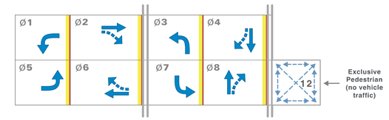
Figure 2 Ring Barrier Diagram for Exclusive Pedestrian Phase
(Source: Koonce et al., 2008)

Literature Review
A number of studies have analyzed the impacts of implementing an exclusive pedestrian phase on pedestrian safety. Vaziri found a 66% reduction in pedestrian-vehicle crashes at high-volume locations in Beverly Hills, CA post Barnes Dance implementation (Vaziri, 1996). Vaziri suggested that this strategy may be best suited for intersections with high volumes of pedestrians and turning vehicles (Vaziri, 1996). Using conflicts between pedestrians and vehicles as surrogate safety measures, Garder found that the Barnes Dance increased safety at those locations where pedestrian signal compliance was high (Garder, 1989). Garder noted that pedestrian signal non-compliance may increase due to scramble phasing (Garder, 1989). Zaidel and Hochermann found that pedestrian safety was not affected due to scramble phasing at intersections with low vehicle volumes in Israel. They also stated that at low volume intersections, pedestrians were less likely to wait for the exclusive pedestrian phase, instead they were more likely to cross due to the available gaps in vehicle traffic flow (Zaidel and Hocherman, 1989). Zegeer and Cynecki found high rates of pedestrian signal violations at intersection with low traffic and pedestrian volumes (Zegeer et al., 1985). Abrams and Smith found that scramble phasing may not be suited for narrow intersections (Abrams and Smith, 1977). Bechtel evaluated the impacts of a Barnes Dance implementation in Oakland, California and found a 50% reduction in pedestrian-vehicle conflicts, which was statistically significant. They also found a statistically significant increase in pedestrian violations (Bechtel et al., 2004). Kattan et al. also studied scramble phasing at two intersections in Calgary, Canada and found that while pedestrian-vehicle conflicts were reduced, pedestrian non-compliance increased (Kattan et al., 2009). Chen et. al. evaluated the effectiveness of four signal related pedestrian countermeasures in New York City – increasing cycle length, Barnes Dance, split phase timing and signal installation (Chen et al., 2012). Their findings revealed that while Barnes Dance was effective in reducing pedestrian crashes, it may potentially increase vehicle crashes (Chen et al., 2012).

Impacts
Safety impacts resulting in reduction of pedestrian-vehicle conflicts can be expected as a result of the Barnes Dance implementation, as evidenced by the literature review results. The literature also points to increase in pedestrian signal non-compliance. Our research findings on the efficiency impacts indicate significant increases in delays for all users – motor vehicles, heavy vehicles, bicyclists, and pedestrians as a result of the Barnes Dance implementation. The increase in delays are due to increase in cycle length.

Implementation
Since the benefits are primarily safety related, this strategy is best suited for intersections with high volume of pedestrians and turning vehicles and locations, possibly in downtown areas, where traditional pedestrian accommodation does not work well. The costs associated with this strategy in terms of increased delays, and increase in pedestrian non-compliance behavior should be carefully weighed against the reductions in pedestrian-vehicle conflicts before deciding to implement this strategy.

Free Operation
In free operation, each intersection operates independently of adjacent intersections and follows the constraints of actuated control, min green, max green, and vehicle extension timers. The advantage of free operation is that individual intersections can be optimized without consideration of other signals, thus allowing greater flexibility and responsiveness (Urbanik, et al. 2015). Good detection on all approaches is necessary for high operational and safety performance (Koonce, et al. 2008).

Literature Review
There is limited research on the impacts of operating the signal in free mode compared to traditional coordination. Kothuri et al. evaluated the impacts of coordination vs. free operation via micro-simulation and found that pedestrian delays are significantly reduced for minor street phases during free operation. Using field derived inputs –volume to capacity ratios for the major street and pedestrian phase actuations for the minor street (proxy for pedestrian demand), Kothuri et al. proposed a methodology for determining if a signal should be coordinated or free, considering overall delay across all users at an intersection (Kothuri et al., 2015). Figure 3 shows the graphic based on the methodology.
    - Impacts
Changing the signal to free operation is primarily an efficiency strategy. Therefore, while the safety impacts of this strategy are unknown, this strategy is not expected to impact safety substantially. Previous work by Kothuri et al. found lower delays across all users when v/c ratios for the major street were below 0.5 (Kothuri et al., 2015). Our current research corroborates these findings and indicates that there may be a tradeoff with the free operation, with increase in major street delays and reduction in minor street delays for pedestrians and vehicles as compared to traditional coordinated operation (Sobie et al., 2016).
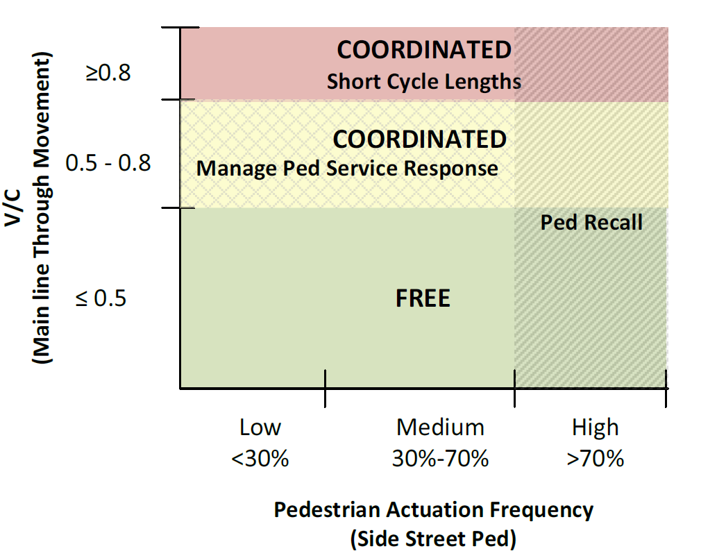
Figure 3 Free vs. Coordinated Operation based on Real Time Field Inputs
(Source: Kothuri et. al, 2015)

Implementation
Free operation may be best suited for intersections with long spacing (half a mile or more) where vehicular coordination is not a high priority. It can also be applied at any intersection based on a time of day approach, in order to prioritize minor street pedestrian movements. Free operation may be used during the off-peak periods to reduce pedestrian delays as well as during late-night hours when traffic volumes on the major street are low. It may also be best suited for intersections where the volumes on the intersecting streets are more balanced.

Short Cycle Lengths
Cycle length in signal timing refers to the time taken for a complete sequence of signal indications (Koonce et al., 2008). Cycle length is an important signal timing parameter especially for coordinated signal systems. The HCM provides an equation to estimate pedestrian delay based on cycle length and effective green time for pedestrians (Transportation Research Board 2010).
$$delay= \frac{({C-g_{walk})}^{2}}{2C}$$
Where C = cycle length, g_{walk} = effective walk time

Literature Review
Research has shown that in general, shorter cycle lengths benefit pedestrians leading to lower delay (Ishaque and Noland, 2005, Ishaque and Noland, 2007, Vallyon et al., 2011, Kothuri et al., 2013). Other guides such as the NACTO’s Urban Street Design Guide and the PEDSAFE also recommend the provision of shorter cycle lengths to encourage signal compliance and increase efficiency (NACTO, 2013, FHWA, 2016).

Impacts
The impacts of shorter cycle lengths on safety have not been studied. Shorter cycle lengths reduce delays for minor street pedestrian and vehicle phases. However, delays for the major street may increase due to the reduction in green time, thus representing a tradeoff in delays between major and minor street phases.

Implementation
This strategy is best suited for off-peak and other periods when vehicular demand is low, yet agencies want their signals to remain in coordination rather than setting them free. Even during peak periods, when vehicular demands are high, keeping the cycle lengths are short as possible is recommended, especially to reduce minor street delays.

Actuated Coordination
In traditional coordination, the through phases on the major street are not actuated. This results in the signal controller being less responsive and flexible because the coordinated phases are not permitted to gap out. Actuating the coordinated phase is a signal timing treatment that allows the user to actuate a portion of the coordinated split (Urbanik et al., 2015). This allows the coordinated phases to gap out if there is low demand during the actuated portion, thus allowing the signal to be more responsive to field conditions. This additional time can be used by the minor street or left turn phases. Figure 4 shows the ring barrier diagram for actuated coordination. In Figure 4, the latter portion of coordinated phases 2 and 6 are actuated and can terminate if there is low demand, while serving phases 3, 7, 4 and 8 earlier.

Literature Review
Day et al. studied the impacts of actuated coordination at an intersection in Noblesville, Indiana on hourly volumes, green time durations, v/c ratios and arrival types (Day et al., 2008). Their findings revealed minor impacts on arrival type, however the additional green time for the minor street phases resulted in decreased v/c ratios and fewer occurrences of split failures (Day et al., 2008). In another study, Day et al. found that using fixed force-offs and fully actuated coordination reduced delays for the non-coordinated phases (Day et al., 2014). Sobie et al. evaluated the impacts of various pedestrian control strategies including actuated coordination in a micro-simulation environment (Sobie et al., 2016). Their results revealed that compared to traditional coordination, actuated coordination decreased the minor street pedestrian delay.

Impacts
The use of fully actuated coordination and fixed force-offs can produce reductions in minor street delays for vehicles, when minor street demand is high. Pedestrian delays on the minor street phases may also decrease as a result of actuated coordination, especially when the major street vehicular demand is low.
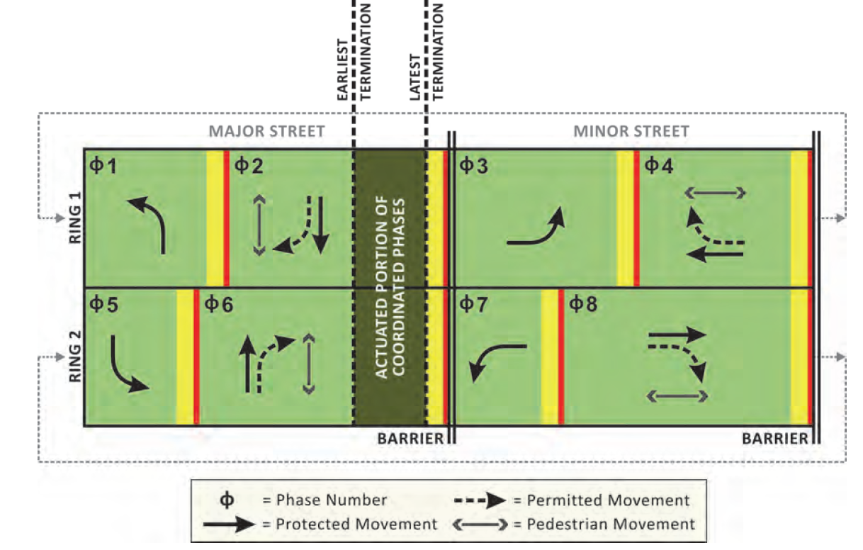
Figure 4 Ring Barrier Diagram Showing Actuated Coordination

Implementation
This strategy may be most useful when agencies want their intersections to remain in coordination, even during off-peak periods. The largest benefits may be seen during periods when the major street demand is low and minor street demand is high. However, presence of mainline detection is necessary for implementation. The increased cost of additional detection and maintenance should be carefully considered prior to implementing this strategy. Day et al. state that the increased cost of mainline detection is offset by a net benefit due to improved efficiency (Day et al., 2014).

Pedestrian Priority Algorithm
Many signal controllers provide users with the ability to incorporate custom logic commands, which allow for greater flexibility in operation. These logic commands can be successfully leveraged to build simple algorithms that provide the user with the flexibility to change modal priorities at the intersection based on real time inputs.

Literature Review
Sobie et al. describe the development and implementation of a pedestrian priority algorithm using the logic processor on an ASC/3 controller. The traffic responsive algorithm is designed to change the operational plan of a traffic signal to a plan which is favorable to pedestrians when vehicular volumes drop below a certain threshold (Sobie et al., 2016). Their findings revealed that the algorithm was successful in reducing minor street pedestrian delays.

Impacts
The algorithm is flexible in that it allows the user to choose an operational strategy which would be enabled based on the volume threshold that is also user defined. Thus, the impacts are dependent on the particular strategy that the user decides to employ.

Implementation
This algorithm can be implemented at any intersection that has a signal controller with the logic command capability. Although the logic commands were constructed on an ASC/3 platform, they can be easily adapted to other signal controller platforms. The algorithm in its current form is best suited for coordinated intersections, with higher major street and lower minor street volumes.

Other Strategies
Permissive length is another signal timing parameter that impacts the delays on minor street movements. Permissive length is defined as a period of time after the yield point where a call on a non0coordinated phase can be serviced without delaying the start of the coordinated phase (Koonce et al., 2008). Increasing the permissive length can reduce pedestrian delays on the minor street movements.

Literature Review
De Castro-Neto evaluated three coordination modes
- Simultaneous fixed permissive point and maximum permissive periods and coordinated, resting in walk
- Sequential fixed permissive point with short permissive periods and coordinated, resting in don’t walk
- Simultaneous fixed permissive point with short permissive periods and coordinated, resting in walk
Three scenarios were used with varying v/c ratios for the non-coordinated phases. The results revealed that all three coordination modes performed similarly during moderate-high traffic volume conditions (de Castro- Neto, 2005). For low volume conditions, having the permissive period close later in the cycle was better for the non-coordinated phases. Kothuri et al. investigated the impacts of increased permissive length at two intersections in Portland, OR (Kothuri et al., 2013). Their results indicated that pedestrian delay for the non-coordinated phases was significantly reduced with increase in permissive length.

Impacts
Vehicular delays for the coordinated phases may be impacted depending on the magnitude of change in the permissive period. More research is needed to fully understand these impacts. Pedestrian delay for the non-coordinated phases is reduced as a result of increase in permissive period. Vehicular delays for the non-coordinated phases could also reduce, since late arriving vehicles could be served in the same cycle.

Implementation
Changing the permissive length is another tool in the toolbox of pedestrian control strategies that engineers could use to reduce delays for the non-coordinated phases (vehicle and pedestrian). This strategy can be employed on a time of day basis to conceivably reduce pedestrian delays for the non-coordinated phases during the off-peak periods.

Comparison of Strategies
Based on the simulation results, a ranking of control strategies that were tested was undertaken based on impacts on minor street pedestrian delay and major street vehicle delay. Table 1 and Table 2 show the ranking of the control strategies based on major street vehicular delays and minor street pedestrian delays. Higher numbers indicate increased delays. For pedestrians, free operation resulted in the lowest delays and Barnes Dance produced the highest delay. For vehicles, coordination produced the lowest delay for the major street phases and Barnes Dance resulted in the highest delay. These rankings are based on the outcome of specific parameter assumptions made during the simulation. It is conceivable, that the rankings may slightly change if other parameters are assumed. However, the general trend shown here is expected to hold.
Table 1 Ranking of Control Strategies based on Major Street Vehicle Delay

Control Strategy | Vehicle Delay Ranking (1 lowest)
Coordination | 1
Actuated coordination | 2
Short cycle lengths | 3
Increase in Permissive Lengths | 4
Free operation | 5
Leading pedestrian intervals | 6
Barnes dance | 7

Table 2 Ranking of Control Strategies based on Minor Street Pedestrian Delay

Control Strategy | Pedestrian Delay Ranking
Free operation | 1
Short cycle lengths | 2
Increase in Permissive Lengths | 3
Leading pedestrian intervals | 4
Actuated coordination | 5
Coordination | 6
Barnes dance | 7

Conclusions
Traditional signal timing practices often prioritize vehicular movements at signalized intersections over other system users. However, an increase in non-motorized modes especially in urban areas had led to greater consideration of the actual operating environment and incorporating the needs of all users. In this guidebook, a number of pedestrian focused signal control strategies were presented along with expected impacts and recommendations on when and where they should be implemented. Generally, there is no one “right solution” for all situations. Implementation of a control strategy depends upon operational objectives and intersection characteristics. Ultimately tradeoffs in delays between user groups may be warranted to prioritize different modes based on time of day.

REFERENCES

Abrams, Charles M, and S A Smith. "Selection of pedestrian signal phasing." Transportation Research Record: Journal of the Transportation Research Board Transportation Research Board 629, Transportation Research Board of National Academies, Washington DC, pp 1-6, 1977.

Bechtel, Allyson, Kara MacLeod, and David Ragland. 2004. "Pedestrian scramble signal in Chinatown neighborhood of Oakland, California: an evaluation." Transportation Research Record: Journal of the Transportation Research Board 1878, Transportation Research Board of National Academies, Washington DC, pp 19-26.

Chen, L., Chen, C., and R. Ewing. The Relative Effectiveness of Pedestrian Safety Countermeasures at Urban Intersections: Lessons from a New York City Experience. In Proceedings of the 91st Annual Meeting of the Transportation Research Board, Transportation Research Board of National Academies, Washington DC, 2012.

Day, Christopher, Edward Smaglik, Darcy Bullock, and James Sturdevant. "Quantitative evaluation of fully actuated versus nonactuated coordinated phases." Transportation Research Record: Journal of the Transportation Research Board, Vol 2080, Transportation Research Board of National Academies, Washington DC, 2008, pp 8-21.

Day, Christopher, and Darcy Bullock. 2014. "Design Guidelines and Conditions That Warrant Deployment of Fully Actuated Coordination." Transportation Research Record: Journal of the Transportation Research Board (2439): 1-11.

Fayish, Aaron, and Frank Gross. 2010. "Safety Effectiveness of Leading Pedestrian Intervals Evaluated by a Before-After Study with Comparison Groups." Transportation Research Record: Journal of the Transportation Research Board (2198): 15-22.

Federal Highway Administration. PEDSAFE Pedestrian Safety Guide and Countermeasure Selection System. Accessed at http://www.pedbikesafe.org/PEDSAFE/countermeasures_detail.cfm?CM_NUM=45
Gårder, Per. 1989. "Pedestrian safety at traffic signals: a study carried out with the help of a traffic conflicts technique." Accident Analysis & Prevention (Elsevier) 21 (5): 435-444.

Houten, Ron Van, Richard Retting, Charles Farmer, and Joy Houten. 2000. "Field Evaluation of a Leading Pedestrian Interval Signal Phase at Three Urban Intersections." Transportation Research Record: Journal of the Transportation Research Board (1734): 86-92.

Hubbard, Sarah L, Ramzi J Awwad, and Darcy M Bullock. 2007. "Assessing the Impact of Turning Vehicles on Pedestrian Level of Service at Signalized Intersections: A New Perspective." Transportation Research Record 27-36, Journal of the Transportation Research Board, Transportation Research Board of the National Academies, Washington DC, 2007

Hubbard, S., Bullock, D., and F.L. Mannering. Right Turns on Green and Pedestrian Level of Service: Statistical Assessment. Journal of Transportation Engineering, Vol 135 (4), American Society of Civil Engineers, April 2009.
Ishaque, Muhammad Moazzam, and Robert Noland. 2005. "Multimodal microsimulation of vehicle and pedestrian signal timings." Transportation Research Record: Journal of the Transportation Research Board (National Academy of Sciences) (1939): 107-114.

Ishaque, Muhammad Moazzam, and Robert B Noland. 2007. "Trade-offs between vehicular and pedestrian traffic using." Transport Policy (Elsevier) 14 (2): 124-138.

Kattan, Lina, Shanti Acharjee, and Richard Tay. 2009. "Pedestrian Scramble Operations: Pilot Study in Calgary, Alberta, Canada." Transportation Research Record: Journal of the Transportation Research Board (National Academy of Sciences) (2140): 79-84.

King, Michael R. 1999. "Calming New York City Intersections." Transportation Research Circular E-C019: Urban Street Symposium ( Transportation Research Board)
Koonce, P., Rodegerdts, L., Lee, L., Quayle, S., Beaird, S., Braud, C., Bonneson, J., Tarnoff, P., and Urbanik, T. Traffic Signal Timing Manual, FHWA-HOP-08-204, 2008.
Kothuri, S., Koonce, P., Monsere, C., and T. Reynolds. Exploring Thresholds for Timing Strategies on a Pedestrian Active Corridor. Proceedings of the 91st Annual Meeting of the Transportation Research Board, Transportation Research Board of National Academies, Washington DC, 2015.
Kothuri, Sirisha, Titus Reynolds, Christopher Monsere, and Peter Koonce. 2013. "Testing strategies to reduce pedestrian delay at signalized intersections: A pilot study in Portland, Oregon." Transportation Research Board 92nd Annual Meeting. no. 13-3854.

NACTO, National Association of City Transportation Officials. 2013. Urban Street Design Guide. New York.

Saneinejad, Sheyda, and Janet Lo. 2015. "Leading Pedestrian Interval Assessment and Implementation Guidelines." Transportation Research Board 94th Annual Meeting.

Sobie, C., Smaglik, E., Sharma, A., Kading, A., Kothuri, S., and P. Koonce. Managing User Delay with a Focus on Pedestrian Operations. Forthcoming in Transportation Research Record, Journal of the Transportation Research Board, Transportation Research Board of the National Academies, Washington DC, 2016.
Transportation Research Board. Highway Capacity Manual 2010.
Urbanik, T., Tanaka, A., Lozner, B., Lindstrom, E., Lee, K., Quayle. S., Beaird, S., Tsoi, S., Ryus, P., Gettman, D., Sunkari, S., Balke, K., and D. Bullock. Signal Timing Manual, Second Edition. NCHRP Report 812.
Vallyon, Chris, Shane Turner, and Steve Hodgson. 2011. Reducing pedestrian delay at traffic signals. NZ Transport Agency.

Vaziri, B (1996) Exclusive pedestrian phase for the business district signals in Beverly Hills, 10 years later. Beverly Hills: Beverly Hills Engineering Department.

Zaidel, David M, and Irit Hocherman. 1987. "Safety of pedestrian crossings at signalized intersections." Transportation Research Record 1141: 1-6.

