National Street Improvements Study:

Indianapolis, IN Report

Introduction
Across the country, policymakers and planning departments are making cities more livable by better accommodating people who walk and bike. Improving streets and upgrading transportation infrastructure often require reducing on-street parking or traffic lanes. While studies have shown how such upgrades improve traffic safety and mobility for city residents, the question remains how such infrastructure improvements affect economic outcomes.
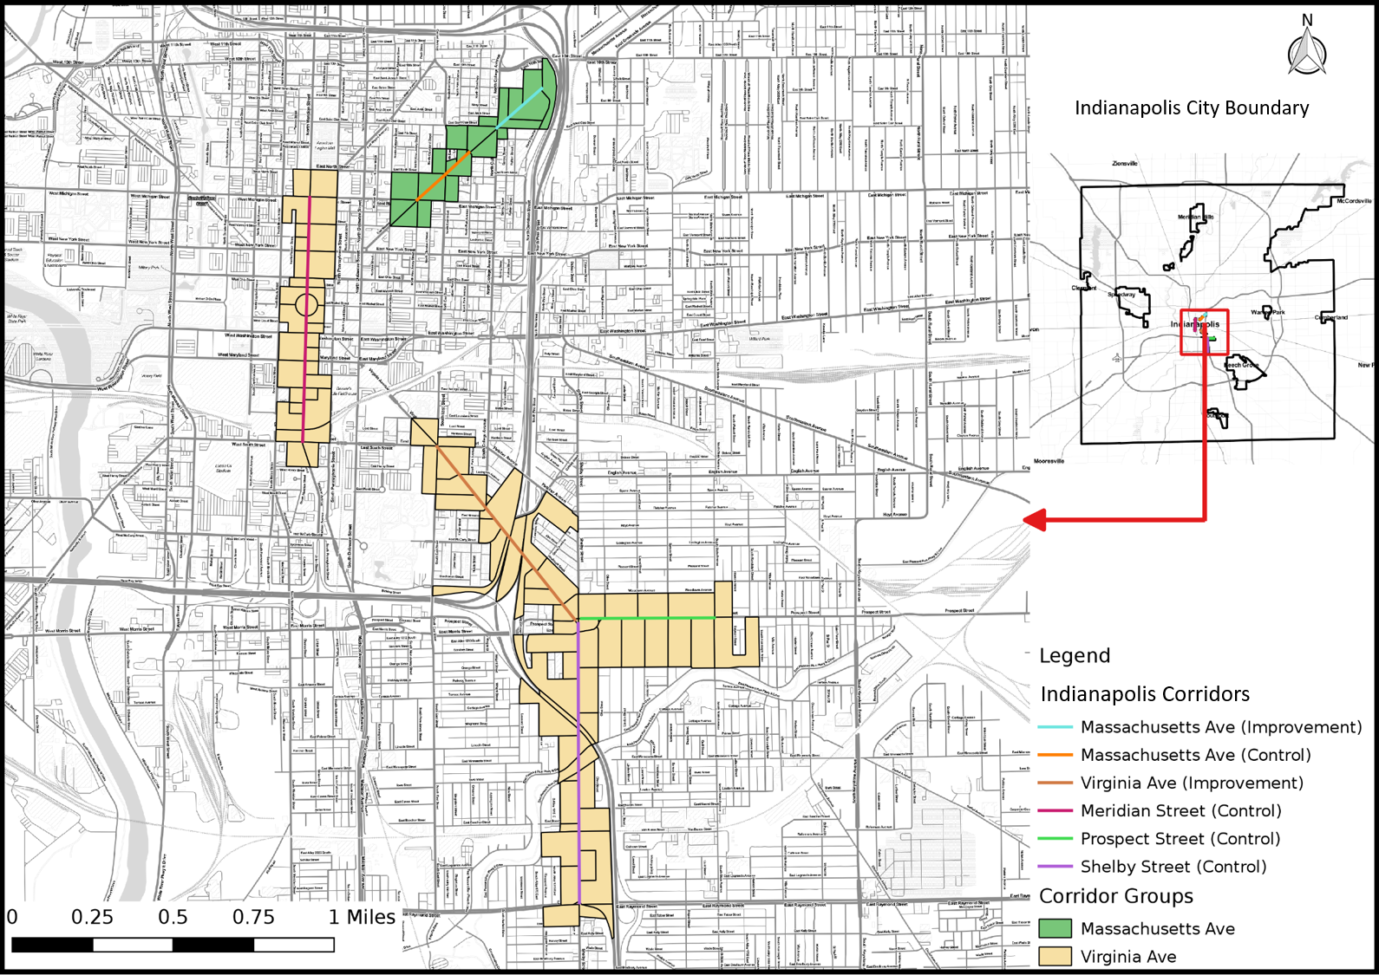
Figure 1-1. Indianapolis Corridors Map

Active transportation advocates often assert that the improvement of active transportation infrastructure will largely increase the number of customers that can arrived via alternative modes in addition to automobiles, and, ultimately, lead to greater revenue and employment growth. While there is some suggestive evidence of this, ranging from self-supported surveys of business owners (Flusche 2012; Jaffe 2015; Stantec Consulting 2011) to consumer behavior surveys (Clifton et al. 2012; Bent and Singa 2009) before and after the installation of active transportation projects. Recently, a few studies have approached this research question by comparing sales tax or employment trends over time for on the improved blocks (NYCDOT 2013; Rowe 2013; Poirier 2017). However, while some researchers have started employing quasi-experimental methodologies (Dill et al. 2014; Yu et al. 2018), the majority have been descriptive or exploratory in nature, or have been limited to case studies within specific urban areas. The validity concerns and lack of consistent data backing many of the previous studies have given the pause and reason to call for additional research and evidence to address the data and methodological concerns.
This study will attempt to answer to what extent these types of corridor-level street improvements impact economic activity and business vitality in the immediate vicinity. Utilizing systematic data sources and methodologies across multiple cities and corridors, we examine, in particular, how do street improvements impact retail sales and employment?
Indianapolis has conducted many street improvement projects in past years, including new bike lanes and road diets. Starting in 1999, Indianapolis began the planning process for the Indianapolis Cultural Trail, an 8-mile long pedestrian and bike trail connecting six historic district in the city. The trail included many street improvements such as protected bike lanes, pedestrian improvements and public art installations. Indianapolis Cultural Trail, Inc., the non-profit organization managing the trail, completed construction in 2013. In addition to the trail, Indianapolis Cultural Trail, Inc. also runs Pacers Bikeshare. The construction of the trail and bikesharing infrastructure have dramatically changed the transportation choices in downtown Indianapolis. In particular, this report explores two recent street improvement corridors - Massachusetts Avenue and Virginia Avenue - to understand the economic and business impact of these active transportation infrastructure investments.

Data Sources/Methodology

Data Sources
For this study we used multiple data sources to estimate the effect of new bike lane infrastructure investment. Because this project makes use of a variety of different data sources, it required collaboration between the research team and representatives from multiple agencies/departments. Our principle contact was with Indianapolis Cultural Trail, Inc. Sales tax data was provided by Indianapolis Cultural Trail, Inc. and QCEW data was retrieved from the State of Indiana and aggregated by the Indiana Bureau of Research Center; and LEHD data was publicly available at the United State Census Bureau.
First, we used the Longitudinal Origin-Destination Employment Statistics (LODES) data set from the Longitudinal Employer-Household Dynamics Dataset (LEHD). It integrates existing data from state-supplied administrative records on workers and employers with existing census, surveys, and other administrative records to create a longitudinal data system on U.S employment. This data set tracks Workplace Area Characteristics (WAC), census blocks where people work as opposed to where workers live, for all the census blocks between 2002 and 2015 for most of the states in the US. As such, LEHD provides geographically granular detail about American’s jobs, workers and local economies, allowing us to examine employment by broad industry sector, wage and educational attainment. Some disadvantages of the LODES data set are that in order to guarantee confidentiality block level data is “fuzzed” so the numbers are not exactly the number of jobs, but they are accurate estimates. Additionally, though we get industrial data, it is only provided at the most general level (the equivalent of two digit NAICS codes) so we are unable to isolate specific retail or service employment such as restaurant workers. That being said, the LEHD data set is comprehensive, offers unprecedented geographic detail, and longitudinal allowing for consistent comparisons over time.
This report also takes advantage of establishment level Quarterly Census of Employment and Wages (QCEW) data. Also referred to as ES-202 data, the QCEW is quarterly data submitted by firms to their respective state governments as part of the unemployment insurance system. Employers report their industry code, their number of employees at the site, and gross pay. The individual establishment-level QCEW data is confidential and requires special permission from the state in order to use it and has additional data use restrictions. The QCEW gives us address level data on individual establishments as well as detailed employment information. Unfortunately, getting access to such data can be difficult and differs for each state and has to be presented in a way to preserve confidentiality. As such, we cannot present ultra-detailed industrial information and have further presentation restrictions depending on the state.
Due to data suppression for confidentiality by the state, we were only able to obtain corridor-level food and drinking place employment data aggregated by the Indiana Business Research Center, but not for the retail industry. These aggregated numbers correspond closely to the LEHD data used elsewhere in the report, but with the advantage that the numbers are not “fuzzed” for confidentiality concerns.
Sales tax data was collected as the primary data source to allow us to estimate a more sensitive measure of economic activity than employment (as the decision to hire or fire employees for a firm is often an expensive one, and thus we would expect employment to be a delayed response to changes in economic activities). Some drawbacks of sales tax data are that some states do not have a sales tax or, in states or cities that do have one, the sales tax data is not broken down by specific industry and it is difficult to parse out accurate figures. But the benefits of sales tax data largely outweigh these issues and do offer a more sensitive metric than employment.
Indiana has a general 7% sales tax for all businesses, with additional taxes based on the type of good or service and the city/county where an establishment is located. For example, Marion County, the home county of Indianapolis, has an additional 2% food and beverage tax as well as a 10% accommodations tax. These produce a sales tax range of 7-19% in the city. However, unprepared grocery food and health care items are exempted from tax collection, which may hamper the ability of sales tax data to accurately reflect all retail business vitality.

Methodology
We applied three methods in order to isolate the impact of street improvements on business vitality while controlling for other economic and regional factors. The methods include an aggregated trend analysis (following the NYCDOT study (2013)), a difference-in-difference approach, and an interrupted time series analysis. The time frame used in the analysis for LEHD data is 2004-2015, 2008-2016 for sales data, and 2004-2016 for QCEW data.

Corridor Selection & Comparison
In order to properly isolate the effect of the street improvements we must identify treatment corridors (corridors where the street improvement occurred) and control corridors (corridors that are similar to the treatment corridors except they remain unimproved). Treatment corridors are corridors where new bike or pedestrian related improvements were installed, ideally made up of a minimum of ten adjacent, or intersecting, census blocks with a minimal number of retail and food service jobs. Additionally, we chose street improvement corridors installed between 2008 and 2013 in order to guarantee we have sufficient data (at least three data points pre- and post-treatment) to track pre- and post-treatment economic trends.
Once corridors are selected based on these criteria, further testing is conducted to discern the level of similarity between treatment and control corridors. We compare similarity in two broad aspects: transportation/geography and business activity levels. In terms of transportation/geography characteristics, the corridors should ideally be geographically close to each other, with similar street classification, travel volumes and relative location/role within the city’s road network.
The level of business activity in both retail and food services industries should be similar on treatment and control corridors, and the general patterns of growth trend prior to the street improvement should be similar as well. Furthermore, the ratio of business jobs (defined as the sum of retail and food service industry jobs) to overall number of service jobs on the treatment and control corridors should be at similar levels. These similarity tests include quintile comparisons and statistical tests of the corridor employment to citywide employment ratios and average block level employment on the street improvement corridor and the proposed corresponding control corridors.
Specifically, t-tests are performed on three metrics at the census block level: (a) “business” employment, the sum of retail and food employment; (b) a census block level “business share” metric that is the number of business employment over the sum of other services industry employment such as professional/scientific services, public administration and educational services; alternatively, another business share metric is calculated that includes a smaller share of services employment (including professional/scientific services, administrative/waste management services and arts/accommodation services). As long as one of the business metrics indicates similarity between the treatment and control corridors, we accept the corridor pair as similar enough for this analysis; and (c) a pre-construction annual employment growth rate.
Table 2-1. Corridor comparison indicators and methods
Comparison Category | Indicators | Method
Transportation/  Geography | Geography proximity | Researcher judgement
 | Street classification (travel volume)
 | Role in road network
Business activity | Job percentile brackets to regional average | Statistical test  (t-test)
 | Business jobs share compared to overall jobs
 | Pre-construction employment growth rate

Aggregated Trend Comparison
This first method follows the previous NYCDOT study (NYCDOT 2013), aiming to examine whether the treatment corridors tend to have better business performance than comparison corridors after street improvements. The approach compares the trends of treatment and control corridors in addition to city-wide trends over the full time period for which we have data. If treatment corridors show greater growth rates in employment or sales tax receipts, or a jump in the level of employment or sales, then that would represent a positive impact of the street improvement on business activities. This method is easy to follow and represents the aggregated trend of business activities. However, it lacks the rigor of econometric estimates and statistical tests that explicitly test whether or not the street improvement caused the changes.
We present both absolute and indexed values for all variables. Indexed values are useful when you need to compare values on different scales. For some corridors the differences in employment or sales tax is large and it is not possible to accurately compare those to smaller corridors without indexing. This is especially important for something like sales tax where some corridors have large amounts of taxable sales due to being on a major travel corridor or having a large anchor retailer like a department store.

Difference-in-Difference (DID)
The second method aims to estimate the difference in business vitality of pre- and post-improvement periods between treatment and control corridors within the same time period. This is known as a difference-in-difference (DID) approach (Angrist and Pischke 2009). It is a designed to answer the “but for” question of what a corridor’s economic trajectory would look like, had the streets not been improved. It requires data from pre/post intervention such as panel data (individual level data overtime) or cross-sectional data (individual or group level). The approach looks at the change in the variable of interest in the treatment corridor before and after it is treated. In this case this means looking at some time period before and after a street improvement, and comparing the economic indicators to the control corridor which has not received the street improvement. The difference in growth trajectories between the two periods will give an unbiased estimate of the effect of the treatment. DID is a useful quasi-experimental technique when true randomized experiments are not possible. This approach removes biases in the second period comparisons between the treatment and control corridors that could be the result of inherent differences between these corridors, as well as biases from comparisons over time in the treatment corridor that could be the result of prior trends. A key assumption of DID estimate is that the differences between control group and treatment group would have remained constant in the absence of treatment.
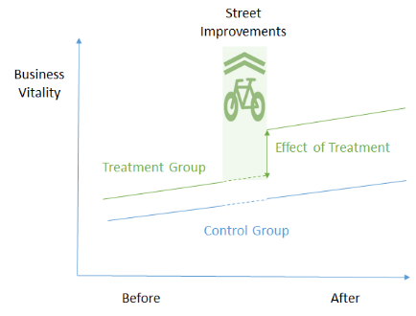
Figure 2-1. Illustration of DID method
DID is a linear modeling approach and its basic formula is expressed as:
$$Y_{it}=β_{0}+β_{1}T_{it}+β_{2}A_{it}+β_{3}T_{it}A_{it}+ε_{it}$$
$Y_{it}$ is the observed outcome in corridors i and t (in this case change in employment or sales tax revenue); $T_{it}$ is a dummy variable set to 1 if the observation is from the treatment corridor, or 0 if the observation is from the control corridor; $A_{it}$ is a dummy variable set to 1 if the observation is from the post-treatment period; $β_{3}$ is the DID estimator of the treatment effect, specified as the prepost:corridor_name coefficient in our analysis. Typically, the DID estimator of interest is $β_{3}$, and if it is estimated to be statistically significant and positive, then this suggests a positive causal effect of the street improvement on the economic indicator in question. Conversely, if the estimate is significant and negative, then that indicates a negative effect of the improvement. Finally, a non-significant result indicates the improvement had no statistically discernible effect.

Interrupted Time Series (ITS)
Interrupted time series (ITS) is an econometric technique that estimates how street improvements impact corridor economic vitality from a longitudinal perspective. This approach tracks the treatment corridor over time and estimates the impact from the street improvement by identifying changes in its growth trend after the treatment (Lopez Bernal et al., 2016). If the treatment has a causal impact, the post-intervention economic indicators will have a different level or slope than the pre-intervention data points. In our research, interrupted-time series will be used to distinguish differences in economic level or growth before and after a specific time period when a street improvement is constructed, such as a new buffered or protected bike lane.
One advantage of ITS is that it allows for the statistical investigation of potential biases in the estimate of the effect of the intervention. Given the longitudinal nature of the test, ITS requires a significantly larger amount of data in order to accurately estimate a real effect on the growth trend.
The interrupted time-series analysis equation can be expressed as:
$$Y_{t}=β_{0}+β_{1}T_{t}+β_{2}X_{t}+β_{3}T_{t}X_{t}+ε_{it}$$
$Y_{t}$ is the observed business outcome in time period t; $T_{t}$ indicates the number of quarters from start to finish of the series; $X_{t}$ is the treatment dummy variable taking on values of 0 in the pre-intervention period and 1 in the post-intervention period; $β_{0}$ is the model intercept or baseline level at t = 0; $β_{1}$ represents the estimated slope (or growth rate) during the pre-intervention period, which we specify as the ts_year coefficient; $β_{2}$ represents the level change following the intervention, specified as the prepost coefficient; and $β_{3}$ indicates the slope change following the intervention, which is the ts_year:prepost coefficient. A positive and statistically significant $β_{2}$ coefficient tends to suggest a positive causal effect on the level of business vitality immediately following the street improvement. A positive and statistically significant $β_{3}$ coefficient would suggest a positive causal effect on the growth in business vitality over time.
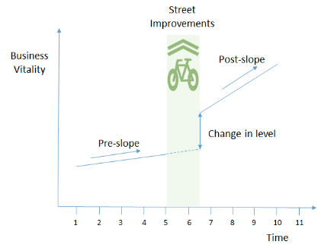
Figure 2-2. Illustration of ITS method

In conclusion, aggregated trend analysis and DID analysis both utilize control corridors to determine the impacts of the street improvement corridor, while the ITS analysis uses multiple time points on the street improvement corridor itself to pinpoint economic outcomes. In general, the ITS analysis provides more robust results than the other two methods, since it is less likely to be affected by the selection of control corridors. However, this method generally requires more data points post-intervention to achieve meaningful and valid impact estimations. The DID approach is heavily dependent on finding comparable control corridors (which may not always exist), so the analytical results may be weakened when appropriate corridors cannot be identified.
Additional data points after the completion of street improvements may help to provide further validity and rigor to the analysis of resulting economic outcomes. Moreover, further contextual information about the street improvement corridor, such as quality or level of the street improvement, number of parking spots eliminated, and subsequent bicycle ridership or pedestrian increases, would help to better understand the linkages between the improvements and potential impacts on business vitality. Extending this research to more closely examine the changes and shifts in industrial patterns will be valuable as well.

Corridor Comparisons
Our first test in corridor comparability is to compare the number of business jobs, retail, and food service industry jobs per block on the corridors to number of jobs per block for the city of Indianapolis as a whole. This is allows us to have a broad understanding of the relative job density of the corridors. This serves two purposes: first, it gives us a quick estimate of the range of employment in each industry on the corridors; and second, it shows how similar the corridors are to each other in terms of economic activities. Finally, we perform a t-test (a statistical test designed to measure if the means of two different groups are statistically similar) on the number of economic indicators, which offers a more rigorous test of the comparability of the corridors. All of the following figures and tables use employment data from the LEHD in the year prior to the street improvement project as the base year for comparison.

Virginia Avenue
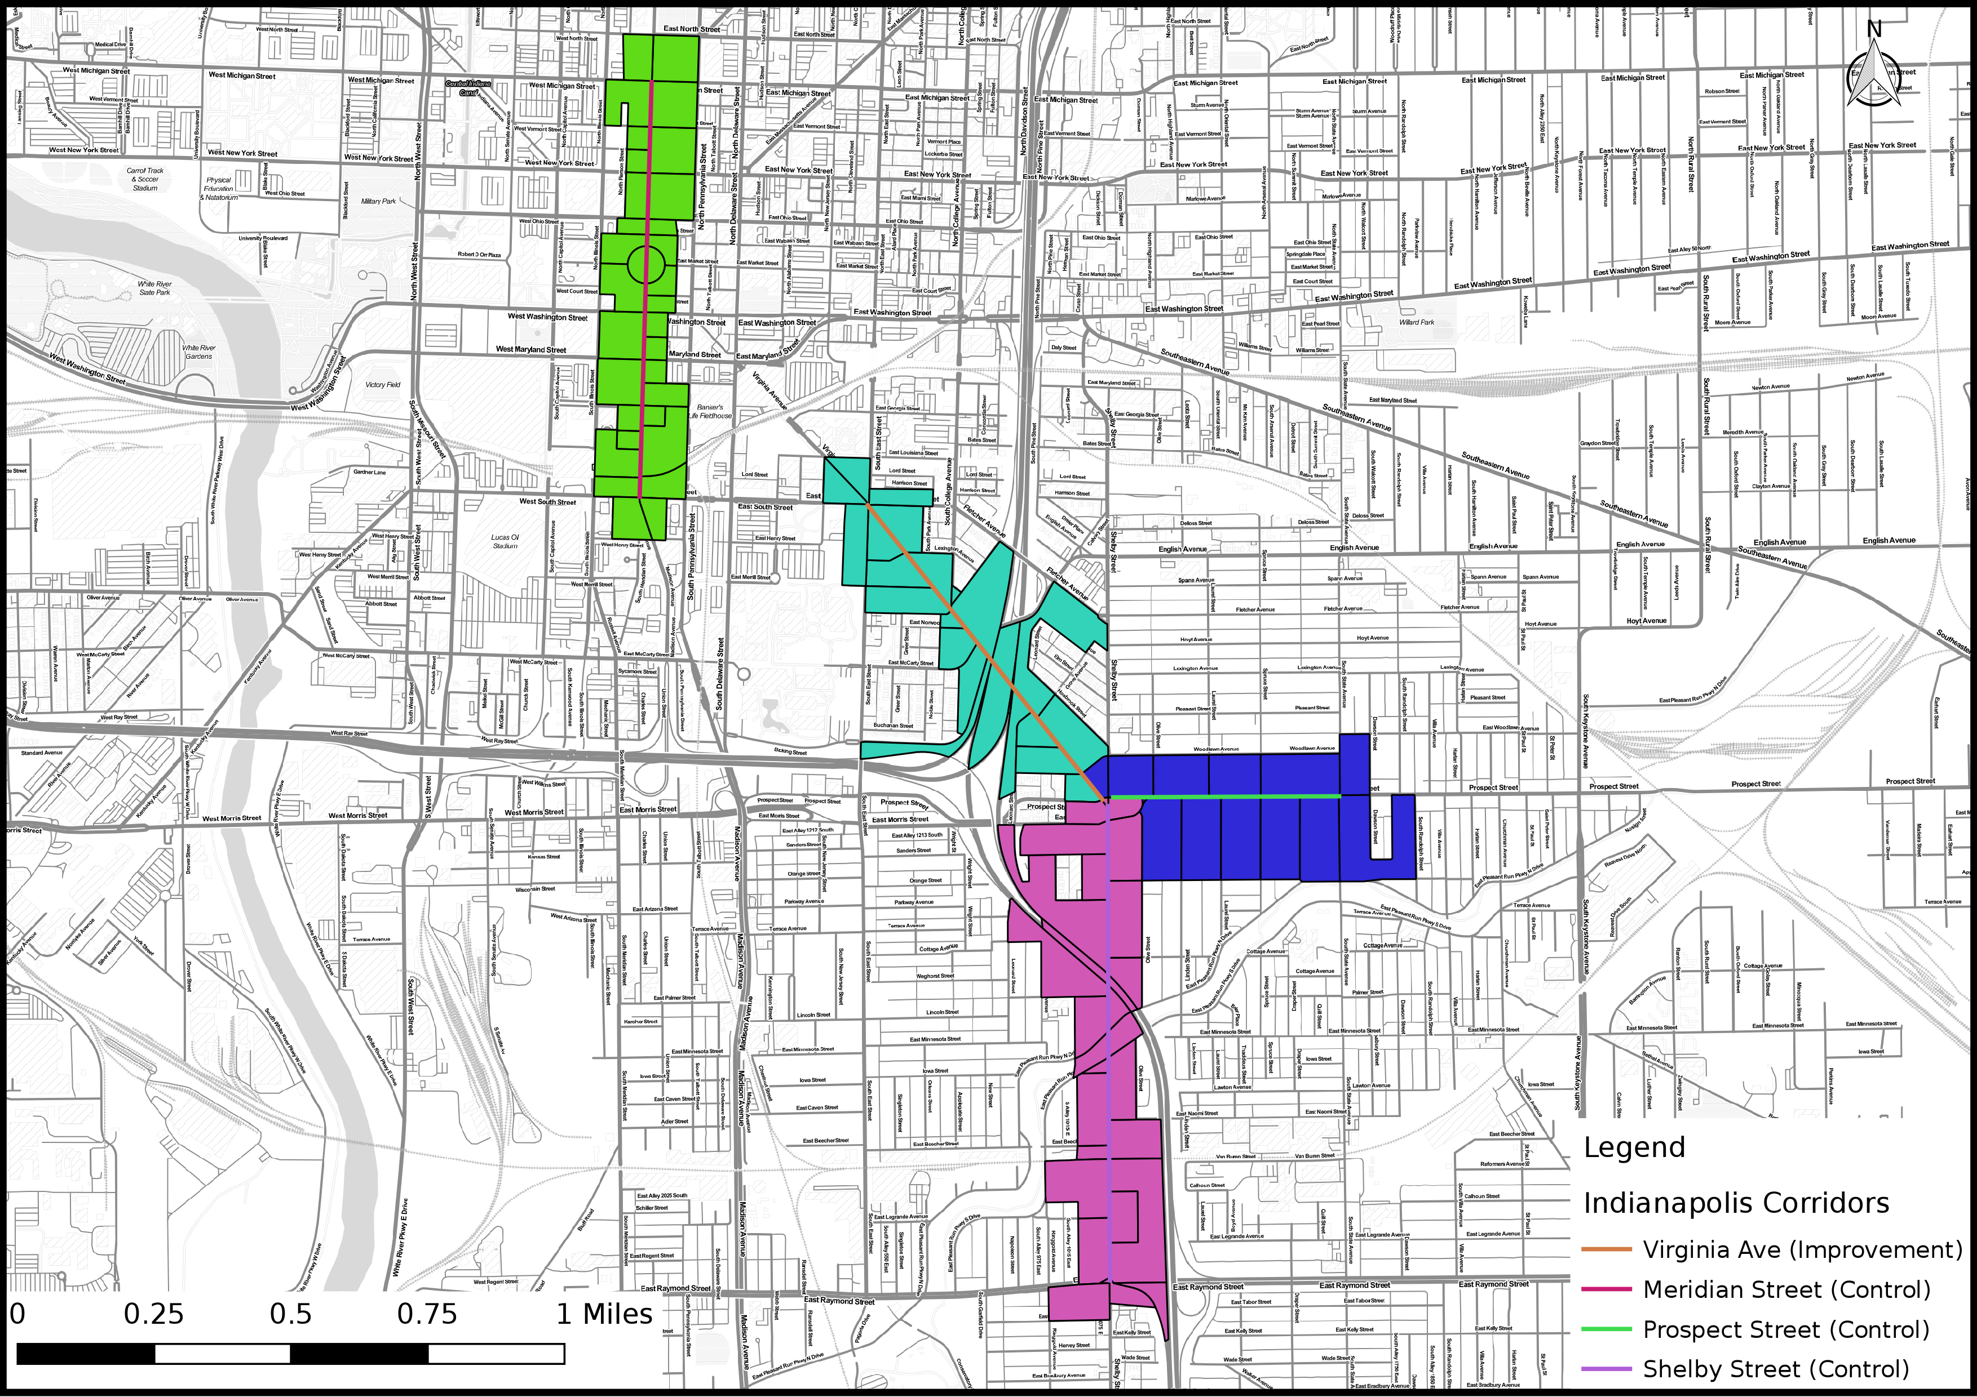
Figure 3-1. Virginia Avenue Corridor
Our first treatment corridor is Virginia Avenue, where a separate bike lane was installed in 2011. The corresponding control corridors are Meridian Street, Prospect Street, and Shelby Street. Prospect Street and Shelby Street are geographically closer to the treatment corridor in southeast downtown Indianapolis while Meridian Street is located in the central downtown area.
The following table shows total, retail, and food employment for Virginia Avenue and the control corridors, as well as the city-based percentile ranks of employment on the corridors. Comparing retail and food services employment, we find that the Meridian Street corridor has much more employment than the Virginia Avenue corridor. The other two comparison corridors, Prospect Street and Shelby Street, have similar levels of employment when compared to Virginia Avenue, but with slightly higher retail employment.
Table 3-1. Virginia Avenue Corridor and Control Corridors Employment Percentiles
 | Employment per block |  |  | Percentiles
Corridor | Total | Retail | Food | Total | Retail | Food
Virginia Ave. | 18 | 1 | 4 | 35-40 | 40-45 | 60-65
Meridian St. | 538 | 32 | 75 | 90-95 | 85-90 | 90-95
Prospect St. | 30 | 5 | 4 | 45-50 | 60-65 | 60-65
Shelby St. | 26 | 6 | 4 | 40-45 | 65-70 | 60-65
We also performed a series of t-tests in order to determine whether the average employment levels per block between the treatment and control corridors are statistically significantly different. The Meridian Street corridor mean ‘business’ and food employment per block is significantly different than the Virginia Avenue corridor blocks, according to our t-tests. Additionally, all other comparison corridors t-tests returned non-significant results, indicating that the corridors have a similar ratios of ‘business’ versus service jobs even though the overall number of jobs on each corridor is different. Based on these statistical tests, it appears that Prospect Street and Shelby Street are comparable and appropriate control corridors for the purposes of our analysis, while Meridian Street is less comparable to the Virginia Avenue corridor.

Massachusetts Avenue
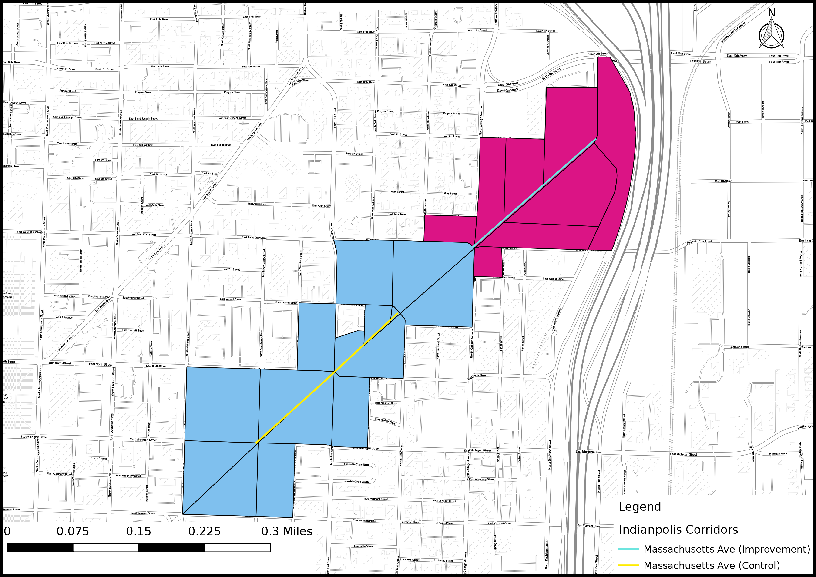
Figure 3-2. Massachusetts Avenue Corridor
The Massachusetts Avenue corridor had a separated bike lane installed in 2009, along with the removal of one travel lane. The proposed control corridor is another section of Massachusetts Avenue that did not experience any street improvements.
The treatment and control corridors have similar levels of employment before the street improvement. The total employment is around 50-55 percentile for the treatment corridor, and 60-65 percentile for the control corridor. Both corridors have relatively fewer retail jobs compared to food services jobs.
Table 3-2. Massachusetts Avenue Corridor and Control Corridor Employment Percentiles
 | Employment per block |  |  | Percentile
Corridor | Total | Retail | Food | Total | Retail | Food
Mass Ave. | 44 | 1 | 17 | 50-55 | 40-45 | 75-80
Mass Ave. (Control) | 73 | 2 | 24 | 60-65 | 45-50 | 80-85
Statistically testing indicates that the two corridors are comparable in terms of business activity level and business/service structure. All t-tests came back non-significant at the 0.05 level, meaning that the two corridors are appropriate comparators.

Corridor Comparison Summary
The following table shows a summary of the corridor comparison analysis for the two treatment corridors and their control corridor groups, with nine comparability indicators for each group. The Prospect Street and Shelby Street corridors are appropriate comparators for Virginia Avenue in terms of transportation/geography comparisons and business activity t-test results. While the Massachusetts Avenue corridors are technically comparable, because they are two legs of the same length of street they will not be suitable for DID analysis, which has requires an assumption of independence.
Table 3-3. Corridor Comparison Summary
Treatment Corridor | Indicator |  | Virginia |  |  | Massachusetts
Control Corridor |  |  | Meridian | Prospect | Shelby | Massachusetts
Transportation/  Geography | Geographic Proximity |  | ✓ | ✓ | ✓ | ✗
 | Street Classification |  | ✓ | ✓ | ✓ | ✓
 | Role in Street Network |  | ✓ | ✓ | ✓ | ✓
Business Activity | Job Density Percentile | retail | ✗ | ✗ | ✗ | ✓
 |  | food | ✗ | ✓ | ✓ | ✓
 | Share of Business Jobs |  | ✓ | ✓ | ✓ | ✓
 | Employment Growth Rate | retail | ✓ | ✓ | ✓ | ✓
 |  | food | ✓ | ✓ | ✓ | ✓

Data Analysis

Virginia Avenue

Aggregated Trend Analysis

LEHD
In terms of retail performance, the Virginia Avenue treatment corridor’s retail employment remains relatively flat over the period of study. In terms of the food sector, the treatment corridor has a similar growth trend to the Prospect Street and Shelby Street corridors before street improvement, but shows substantial employment growth after the construction.
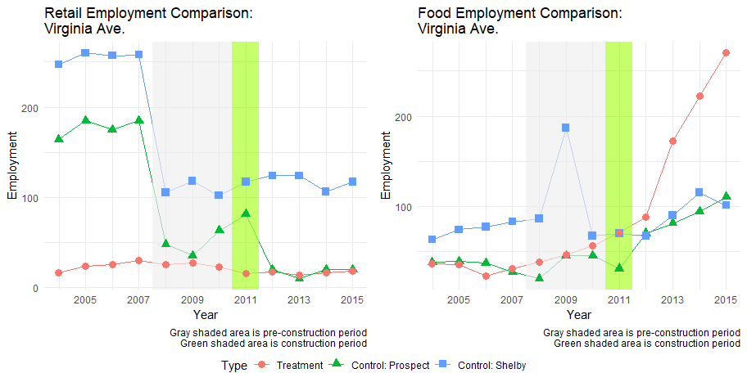
Figure 4-1. Virginia Avenue Employment Comparison (LEHD)
Indexing the employment figures allows us to examine the change in the growth of employment, and compare to the patterns in the city of Indianapolis as a whole. The retail plot shows that Virginia Avenue maintains a consistently level of employment prior to the street improvement, while its control corridors experienced significant drops in the 2008 recessionary period. All corridors saw decreases during the recession and then a rebound of employment in the late 2000s/early 2010s. The treatment corridor does not track any particular comparator corridor that closely, but it is much closer to the city as a whole than the others.
The indexed food employment trend shows a much tighter relationship among the corridors. This should be expected given the relatively small amounts of food employment across the corridors, but Virginia Avenue’s clear, consistent growth starting after 2007, especially after the street improvement construction, is quite stunning when compared to its control corridors. We can conclude that the positive food employment growth on Virginia Avenue could be attributed to the street improvement.
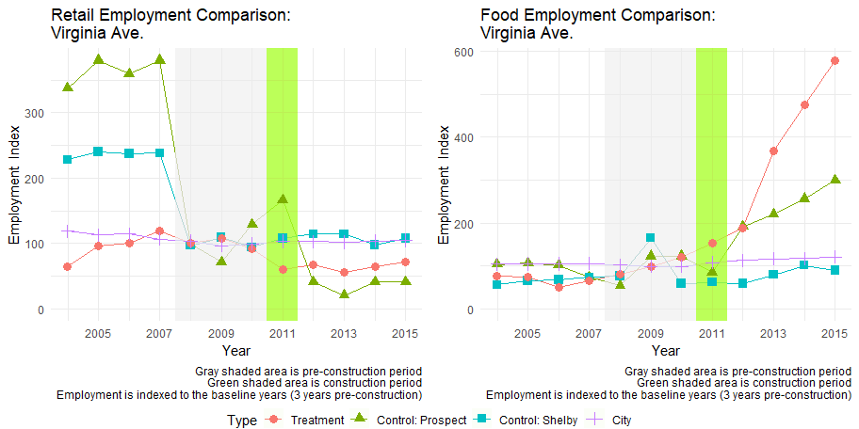
Figure 4-2. Virginia Avenue Indexed Employment Comparison (LEHD)

Sales Tax
In order to better understand the impacts of the street improvement on the corridors, we utilized sales tax data in our analysis. As mentioned previously, sales taxes can be a more sensitive measure of economic activity than employment and the data is typically available on a more frequent basis.
In terms of sales tax revenue and growth patterns, all three corridors are comparable. Virginia Avenue itself sees steady and increasing tax revenue over time with an anomalous spike in 2014, but quickly returns to normal. Shelby Street and Prospect Street generally mirror Virginia Avenue in terms of total tax receipts and also follows the same growth trends, though both have more modest growth over time than Virginia Avenue.
The indexed plots give us an alternative view of the corridors that reinforce what the non-indexed plots show, by highlighting how the economic indicators have changed when compared to the baseline year of 2011 when the street improvement occurred. The consistent growth of sales tax revenue on the improved Virginia Avenue and the relatively weaker growth on Prospect Street and Shelby Street are even more evident in the indexed plots. It is clear that Virginia Avenue continues to experience stellar growth over time.

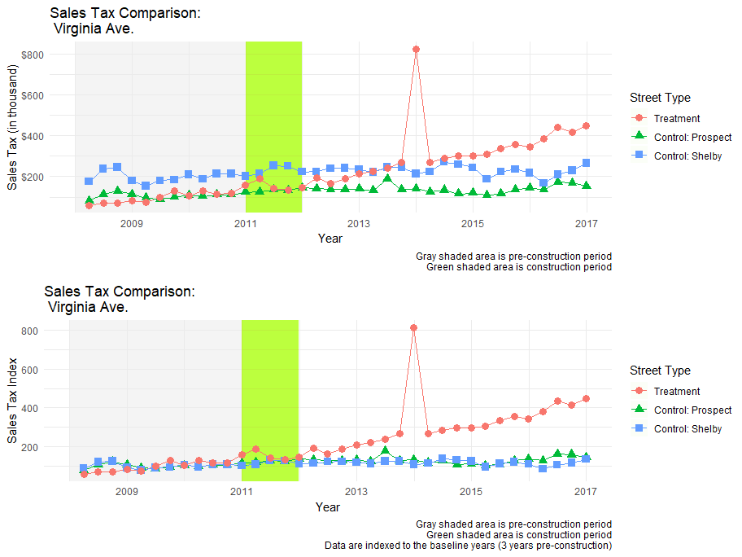
Figure 4-3. Virginia Avenue Sales Tax Comparison (Sales tax data)

QCEW
As mentioned earlier, the QCEW data provided by the state will give us more economic indicators as it includes establishment counts and total wage information for the food and drinking place service industry on the corridors. While we do not have access to fully disaggregated data, the increased sample size and detail on establishments and wages is still valuable and expands our understanding of the economic and business dynamics of our corridors.
In the case of Virginia Avenue, the ability to isolate slightly more detailed industries, in this case food and drinking places (NAICS code 722), gives us a clearer idea of the growth in our industries of interest. For example, the growth in food and drinking places employment is more dramatic than the aggregated trend analysis of other data sources (which include both food service and retail establishments) on Virginia Avenue but the overall pattern remains similar to the analysis of LEHD data.
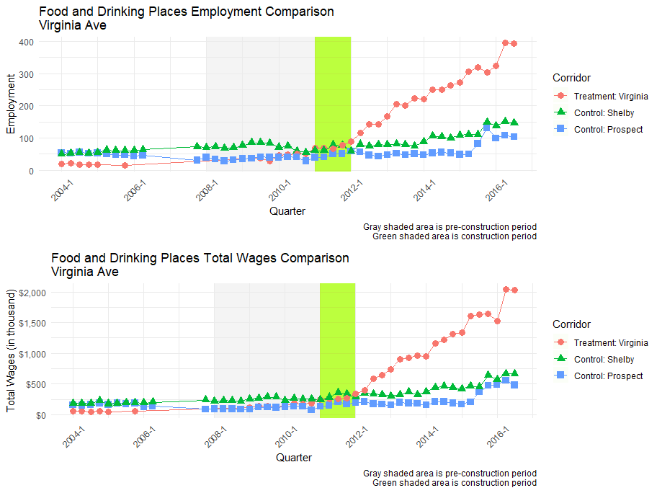
Figure 4-4. Virginia Avenue Employment and Total Wages Comparison (QCEW)
While the basic trend graphs give us an idea of the pattern of growth over time, in this case, consistent employment on Virginia Avenue compared to its comparison corridors, an indexed plot can give us a better idea of changes in growth with every corridor on the same scale. The indexed graphs for employment and indicates a similar trend, that the Virginia Avenue corridor has seen nearly 600% growth in employment after three years of street improvement. Interestingly, the Shelby Street and Prospect Street corridor growth trends also mirror Virginia Avenue well before construction, but do not follow the same extraordinary employment growth trend following the street improvement.
In terms of wages, we find similar patterns, which is to be expected since wages and employment typically track closely together. Virginia Avenue displays dramatic growth again with over 800% rise in total wages reported with steady growth starting from the street improvement construction period.
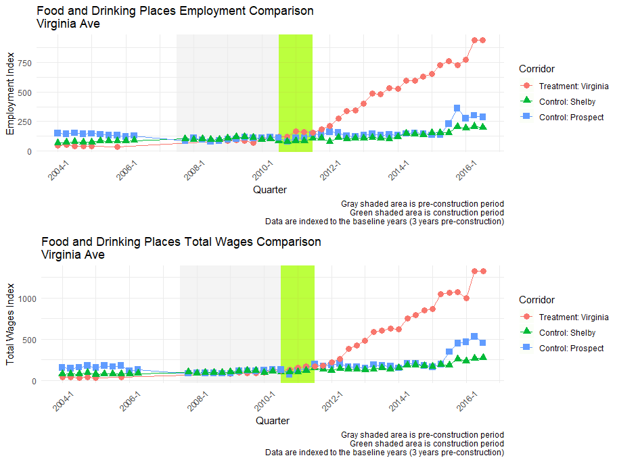
Figure 4-5. Virginia Avenue Indexed Employment and Total Wages Comparison (QCEW)
Table 4-1. Virginia Corridor Trend Analysis Summary Table
Area | Retail |  |  |  |  |  | Food
 | Baseline |  | Post-implementation |  |  |  | Baseline |  | Post-implementation
 | Base | Growth | 1st Year | 2nd Year | 3rd Year | Avg. | Base | Growth | 1st Year | 2nd Year | 3rd Year | Avg.
LEHD: [employment]
Treatment | 25 | -3.41% | -32.00% | -17.65% | 14.29% | -11.79% | 47 | 21.40% | 87.23% | 95.45% | 29.07% | 70.59%
Control: Shelby | 108 | -0.59% | 14.81% | 0.00% | -14.52% | 0.10% | 113 | 26.64% | -40.71% | 34.33% | 27.78% | 7.13%
Control: Prospect | 49 | 26.46% | -59.18% | -50.00% | 100.00% | -3.06% | 37 | 62.50% | 89.19% | 15.71% | 16.05% | 40.32%
QCEW: [employment]
Treatment | - | - | - | - | - | - | 42 | 41.01% | 191.67% | 62.65% | 23.34% | 92.55%
Control: Shelby | - | - | - | - | - | - | 72 | -1.68% | 1.04% | 7.90% | 25.80% | 11.58%
Control: Prospect | - | - | - | - | - | - | 36 | 6.20% | 40.97% | -3.45% | 6.12% | 14.55%
Sales: [sales tax, $]
 |  |  | Baseline |  | Pre-Growth | 1st Year | 2nd Year | 3rd Year | Avg.
Treatment |  |  | 404,527 |  | 37.08% | 87.85% | 104.99% | -25.45% | 55.80%
Control: Shelby |  |  | 794,351 |  | -0.37% | 18.84% | -1.66% | 7.78% | 8.32%
Control: Prospect |  |  | 427,695 |  | 2.00% | 29.41% | 7.63% | -17.10% | 6.65%
The baseline is defined as the average of the three years prior to the construction year;
The pre-growth rate is defined as the average of the baseline annual growth rates;
The post-growth rate is defined as the average annual growth rate of three time points after the construction year.
The table above summarizes the detailed percentage changes of retail and food services economic indicators across three different data sources. Although Virginia Avenue retail employment shows a more negative growth trend when compared with the corresponding control corridors, it shows substantial growth in all food services industry metrics - employment, sales and wages - after bike lane installation.

DID Analysis
DID estimation of LEHD data did not yield any statistically significant results for the Virginia Avenue corridors. The lack of statistically significant terms here leads us to believe there is not a causal relationship between the installation of the new bike lane and change in retail or food employment for Virginia Avenue, and there may be other drivers that contributed to the considerable economic growth on the corridor.
In terms of sales tax, the DID analysis shows significant results when comparing Virginia Avenue to the Shelby Street and Prospect Street corridors, indicating a positive impact of the street improvement on sales volume. This results mirrors what we saw in the visual aggregated trend analysis, with significant increases of in sales tax receipts on Virginia Avenue while the two control corridors remained stagnant.
The QCEW DID analysis results signal positive and significant effects of the bike lane installation on both employment and quarterly wages for Virginia Avenue. In this case, holding all other parameters equal, the street improvement contributes to an increase of 200 jobs and nearly a million dollars in quarterly wages increase compared to Prospect Street and Shelby Street.

ITS Analysis
ITS analysis of the Virginia Avenue corridor using LEHD data does not show any significant level or slope change from the pre-treatment trend patterns. While the ts_year coefficient for food employment is positive and significant, this only tells us that the growth trend of food employment for the corridor is itself positive. The non-significant prepost and ts_year:pre_post indicate that there was neither a level or slope change attributable to the treatment.
In terms of sales tax data ITS results, the non-significant results from prepost and ts_year:pre_post terms give some supportive evidence that the construction was not directly responsible for the increase in sales tax receipts on Virginia Avenue corridor that the DID analysis highlighted. It seems unlikely there is a clear causal relationship between the corridor construction and sales tax effects.
The QCEW ITS model shows a positive and significant effect of bike lane installation on Virginia Avenue for both jobs and quarterly wages. In particular, Virginia Avenue food employment saw a negative, statistically significant drop in employment level after treatment, but there is a positive slope signaling an overall positive growth trend. This result more clearly follows our descriptive data that shows a clear positive growth of employment and wages over time before, during and after the construction period with accelerated growth post-construction. The impact of the street improvement on Virginia Avenue should become clearer as additional data points become available in the future.

Key Results
- Although Virginia Avenue retail employment shows a more negative growth trend when compared with the corresponding control corridors in the aggregated trend analysis, the more rigorous DID and ITS approaches indicate that the bike lane installation did not significantly impact retail employment, either positively or negatively, along the Virginia Avenue corridor.
- The Virginia Avenue corridor shows substantial growth in all food services industry metrics - employment, sales and wages - after bike lane installation. Both DID and ITS models indicate positive causal effects on food service businesses. These positive impacts are supported consistently across all analysis results using all data sources.
- In conclusion, the separated bike lane triggered significant employment, sales, and wage increases in the food services industry, indicating an improvement in business vitality as a result.

Massachusetts Avenue

Aggregated Trend Analysis
The employment trend graphs of the treatment and control Massachusetts Avenue corridors are presented below. In terms of retail employment, the two corridors experienced a significant employment drop around 2007 (with retail employment dropping to zero in 2007 and 2009 on the treatment corridor) and appear to be in the midst of a recovery period but with the treatment corridor lagging in terms of new employment growth. In terms of the food services sector, both the treatment and control corridors show pre-construction drops in employment, but both rebound significantly in the following years. Given the proximity of the corridors, this is to be expected and is reflected by the non-significant t-test results.
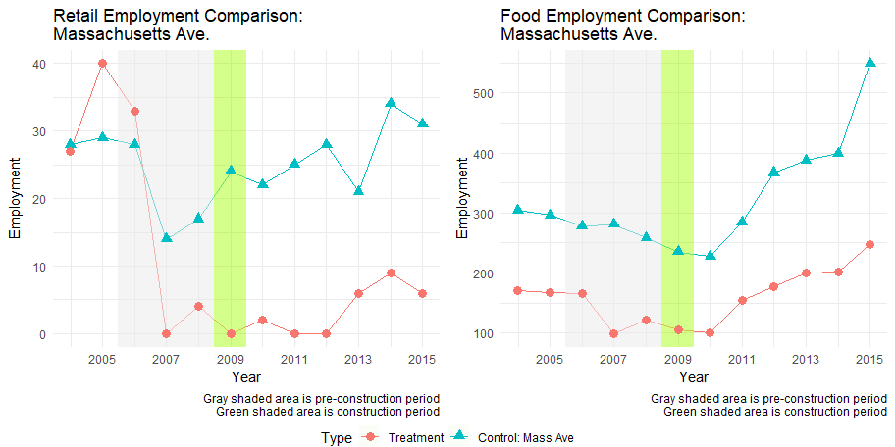
Figure 4-6. Massachusetts Avenue Employment Comparison (LEHD)
Given the low amount of retail employment in treatment corridor, we eliminate the indexed plot of retail employment, and just present the food employment growth indexed plot. The food employment indexed plot below shows the rather vigorous employment growth on the greater Massachusetts Avenue corridor, which appears even more impressive when compared to the city as a whole.
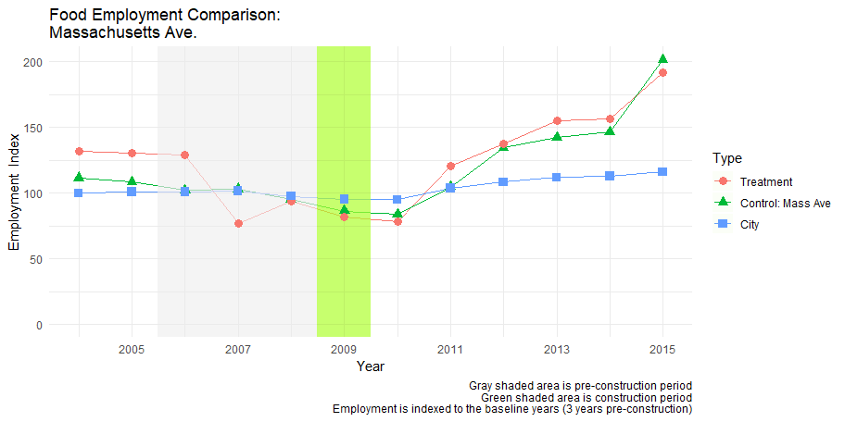
Figure 4-7. Massachusetts Avenue Indexed Employment Comparison (LEHD)

Sales tax
Given their proximal nature, the sales tax receipts on both improvement and control corridors of Massachusetts Avenue are quite similar in level and growth pattern. They run parallel to each other until a separation which occurs around 2013. Both corridors saw a spike in sales tax receipts at this time, but the Massachusetts Avenue control section sees a much larger growth spike and maintains greater sales tax receipts moving forward from that point in time. Beyond that, the two halves of the corridor continue to mirror each other. However, because the sales tax receipt along the two corridors tracked each other very closely for 5 years following the street improvement construction, it is difficult to conclude whether or not the different paths starting in 2013 can be attributed directly to the construction or another event.
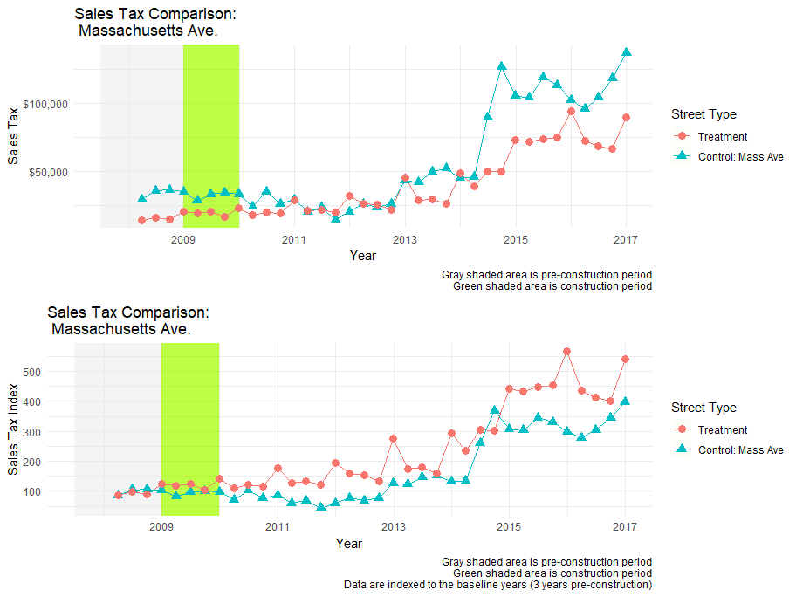
Figure 4-8. Massachusetts Avenue Sales Tax Comparison (Sales tax data)

QCEW
According to the QCEW data, the treatment section of Massachusetts Avenue did not have any food and drinking establishments during the construction period. This does not mean there was no retail oriented employment, the LEHD data shows there was some kind of retail on Massachusetts Avenue, but that there was no food and drinking specific employment. While we do not have data covering the construction period, it is still valuable to note the robust growth in employment and wages for the treatment corridor over a short period of time in the years after the street improvement. It is not possible to use this particular data source to determine whether or not the cycling infrastructure played a causal role in this growth, but the data points to sustained robust employment and wage growth on this commercial corridor with cycling infrastructure.
Due to the lack of data during the construction period, no index values were calculated for this corridor.
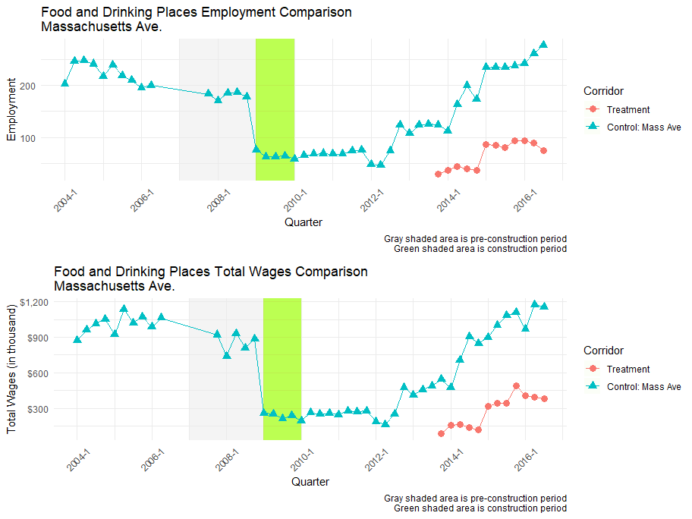
Figure 4-9. Massachusetts Avenue Employment and Total Wages Comparison (QCEW)
Table 4-2. Massachusetts Corridor Trend Analysis Summary
Area | Retail |  |  |  |  |  | Food
 | Baseline |  | Post-implementation |  |  |  | Baseline |  | Post-implementation
 | Base | Growth | 1st Year | 2nd Year | 3rd Year | Avg. | Base | Growth | 1st Year | 2nd Year | 3rd Year | Avg.
LEHD: [employment]
Treatment | 12 | - | - | - | - | - | 129 | -9.07% | -21.71% | 53.47% | 14.19% | 15.32%
Control: Mass Ave | 20 | -14.29% | 10.00% | 13.64% | 12.00% | 11.88% | 273 | -3.38% | -16.48% | 25.00% | 28.77% | 12.43%
Sales: [sales tax, $]
 |  |  | Baseline |  | Pre-Growth | 1st Year | 2nd Year | 3rd Year | Avg.
Treatment |  |  | 66,527 |  | - | 31.25% | 9.99% | 24.85% | 22.03%
Control: Mass Ave |  |  | 137,819 |  | - | -15.68% | -31.19% | 50.81% | 1.32%
The baseline is defined as the average of the three years prior to the construction year;
The pre-growth rate is defined as the average of the baseline annual growth rates;
The post-growth rate is defined as the average annual growth rate of three time points after the construction year.
The table above summarizes the detailed percentage changes of retail and food service economic indicators across three different data sources. While growth in retail employment and sales revenue was observed in the years following the construction of the separated bike lane on Massachusetts Avenue, we are unable to calculate pre- and post-construction growth rates due to zero retail employment in some of the years. In the food services sector, both the improved corridor of Massachusetts Avenue and the control corridor show similar increasing employment trends.

DID Analysis
We did not perform a DID estimation for Massachusetts Avenue, as the corridor comparison process showed that the corridor group is unsuitable for this type of analysis.

ITS Analysis
ITS analysis of the LEHD data indicates Massachusetts Avenue corridor has a significant negative pre_post coefficient for food employment and a significant positive ts_year:pre_post term. This means there was a sharp loss in jobs at the construction point in time, but with greater growth in employment after the street improvement construction than the period prior to construction. However, the year of construction (2009) coincides with the recessionary period, and may confound some of these results. This means that while construction or the recession may have temporarily resulted in employment loss (due to establishments closing during construction or releasing workers due to lower sales during construction), the corridors are now growing at a healthier rate than before. This is a mixed result, but considering the construction of the corridor was still during the Great Recession, the fact that there is still robust growth five years after the street improvement suggests that overall economic conditions have improved and that the construction of the lane may have had a positive contributions to this new growth trajectory.
In terms of the ITS model of sales tax receipts, the pre_post term is negative and significant signaling a change in level of sales tax receipts due to the intervention, but the ts_year:pre_post interaction term is non-significant. The lack of a significant interaction term means that we cannot attribute change in the growth of sales tax on Massachusetts Avenue to the placement of new cycling infrastructure. It should be noted, though, that this sales tax data starts in 2008 so we do not necessarily have enough pre-intervention data points to make a strong statement either way using this technique. That being said, given our model specification, the ITS model does not signal a causal relationship between the change in sales tax receipts and new cycling infrastructure.

Key Results
- In the food services sector, both the improved corridor of Massachusetts Avenue and the control corridor show similar increasing employment trends. The growth on Massachusetts Avenue significantly outpaced food services employment growth in the city as a whole following bike lane installation in 2009. In addition, this growth is confirmed by the positive significant impact on employment growth using the ITS approach.
- While growth in retail employment and sales revenue was observed in the years following the construction of the separated bike lane on Massachusetts Avenue, we are unable to calculate pre- and post-construction growth rates due to zero retail employment in some of the years. However, the DID and ITS approaches both indicate that the bike lane installation did not significantly impact retail employment, either positively or negatively, along this corridor.
- In conclusion, on Massachusetts Avenue, we found a significant positive impact on food services employment following its separated bike lane construction, indicating an improvement in business vitality.

Conclusion
Based on our analysis of the two street improvement corridors in Indianapolis, we found street improvement projects either improve, or had insignificant impacts on, economic outcomes. In particular, we can conclude that:
- Along Virginia Avenue, the more rigorous DID and ITS approaches indicate that the bike lane installation did not significantly impact retail employment, either positively or negatively. However, the corridor shows substantial growth in all food service industry metrics - employment, sales and wages - after bike lane installation. Both DID and ITS models indicate positive causal effects on food service businesses. These positive impacts are supported consistently across all analysis results using all data sources.
- On the improved corridor of Massachusetts Avenue, food services employment growth significantly outpaced growth in Indianapolis as a whole following bike lane installation in 2009. In addition, this is confirmed by the positive significant impact on employment growth using the more rigorous ITS approach.
In terms of retail service sector, we found either mixed results or insignificant results. This is typically due to either insufficient number of data points before or after the completion of the street improvement (for ITS analysis), or control corridors that may not be fully comparable (for DID analysis). However, the insignificant results may be significant in this context, indicating that there does not appear to be a negative causal impact of right-of-way or parking lane removal on economic outcomes.
Three data sources were used for this analysis, each with its pros and cons. The analysis results using the three data sources should be viewed as complementary to each other. LEHD data is comprehensive, easy to access, and provides rough trends of employment change at small geographical scales. It allows for comparisons between the street improvement corridors with overall city economic trends, and for both treatment and control corridor selection without obtaining additional data. Once street improvement corridor selection is completed, sales tax data (sales revenue) and QCEW data (employment and wages) can provide finer grain economic activity details. In Indianapolis, sales tax data may only capture parts of economic activities that are subject to sales tax, because sales of unprepared food and healthcare are tax exempt; and aggregated QCEW data for Indianapolis only identifies the food and drinking places sector (excluding retail service industries).
We employed three different analytical approaches to investigate the economic impacts of street improvement corridors. Aggregated trend analysis and difference-in-difference (DID) analysis both utilize control corridors to determine the impacts of the street improvement corridor, while the interrupted time series (ITS) analysis uses multiple time points on the street improvement corridor itself to pinpoint economic outcomes. In general, the ITS analysis provides more robust results than the other two methods, since it is less likely to be affected by the selection of control corridors. However, this method generally requires more data points post-intervention to achieve meaningful and valid impact estimations. The DID approach is heavily dependent on finding comparable control corridors (which may not always exist), so the analytical results may be weakened when appropriate corridors cannot be identified.
Additional data points after the completion of street improvements may help to provide further validity and rigor to the analysis of resulting economic outcomes. Moreover, further contextual information about the street improvement corridor, such as quality or level of the improvement, number of parking spot reduction, and subsequent bicycle ridership or pedestrian increases, would help to better understand the linkages between the improvements and potential economic impacts. Extending this research to more closely examine the changes and shifts in industrial patterns will be valuable as well.

Special thanks to Indianapolis Cultural Trail, Inc. for the valuable assistance that made this study possible.

Reference
Angrist, Joshua, and Jorn-Steffen Pischke. 2009. Mostly Harmless Econometrics: An Empiricist’s Comparison. Princeton University Press.
Bent, Elizabeth, and Krute Singa. 2009. “Modal Choices and Spending Patterns of Travelers to Downtown San Francisco, California: Impacts of Congestion Pricing on Retail Trade.” Transportation Research Record: Journal of the Transportation Research Board 2115 (December): 66–74. https://doi.org/10.3141/2115-09.
Clifton, Kelly, Christopher Muhs, Sara Morrissey, Tomás Morrissey, Kristina Currans, and Chloe Ritter. 2012. “Consumer Behavior and Travel Mode Choice.” Oregon Transportation Research and Education Consortium. http://kellyjclifton.com/Research/EconImpactsofBicycling/OTRECReport-ConsBehavTravelChoices_Nov2012.pdf.
Dill, Jennifer, Nathan McNeil, Joseph Broach, and Liang Ma. 2014. “Bicycle Boulevards and Changes in Physical Activity and Active Transportation: Findings from a Natural Experiment.” Preventive Medicine 69 (December): S74–78. https://doi.org/10.1016/j.ypmed.2014.10.006.
Flusche, Darren. 2012. “Bicycling Means Business: The Economic Benefits of Bicycle Infrastructure.” League of American Bicyclists. http://www.advocacyadvance.org/site_images/content/Final_Econ_Update(small).pdf.
Jaffe, Eric. 2015. “The Complete Business Case for Converting Street Parking Into Bike Lanes.” 2015. http://www.citylab.com/cityfixer/2015/03/the-complete-business-case-for-converting-street-parking-into-bike-lanes/387595/.
Lopez Bernal, James, Steven Cummins, and Antonio Gasparrini. 2016. “Interrupted Time Series Regression for the Evaluation of Public Health Interventions: A Tutorial.” International Journal of Epidemiology, June, dyw098. https://doi.org/10.1093/ije/dyw098.
NYCDOT. 2013. “The Economic Benefits of Sustainable Streets.” New York City Department of Transportation. http://www.nyc.gov/html/dot/downloads/pdf/dot-economic-benefits-of-sustainable-streets.pdf.
Poirier, Joseph. 2017. “Are Bicycles Good for Business? A San Francisco Examination in Three Case Studies.” University of California, Berkeley.
Rowe, Kyle. 2013. “Measuring the Economic Impact of Bicycle Facilities on Neighborhood Business Districts.” http://bikewalkkc.org/wp-content/uploads/2016/03/Bikenomics_v4.pdf.
Stantec Consulting. 2011. “Vancouver Separated Bicycle Lanes Business Impact Study.” Stantec Consulting Ltd. http://www.peoplepoweredmovement.org/site/images/uploads/penv3-BusinessImpactStudyReportDowntownSeparatedBicycleLanes-StantecReport.pdf.
Yu, Chia-Yuan, Mingjie Xu, Samuel D. Towne, and Sara Iman. 2018. “Assessing the Economic Benefits and Resilience of Complete Streets in Orlando, FL: A Natural Experimental Design Approach.” Journal of Transport & Health 8: 169–78. https://doi.org/10.1016/j.jth.2017.11.005.

Technical Appendix
The following section presents the estimation tables of the difference-in-difference (DID) and interrupted time series (ITS) analysis for each corridor group. The sections are organized by the data source of the model: LEHD, sales tax and QCEW. Please refer to the appropriate sections earlier in the report for descriptions of the data, methodology and interpretation of the results.

Corridor Comparisons
T-statistics of Corridor Comparison test (numbers in parentheses indicate p-value)
Corridor | Job per block |  | Business job share |  | Pre-construction growth rate
 | Retail | Food | Metric 1 | Metric 2 | Retail | Food
Virginia
Meridian | -1.26  (0.218) | -2.884  (0.007) | -0.108  (0.914) | 0.063  (0.949) | 0.579  (0.579) | 0.639  (0.545)
Prospect | -0.894  (0.389) | -0.096  (0.923) | -0.234  (0.816) | -0.100  (0.921) | 0.425  (0.683) | -0.042  (0.967)
Shelby | -1.863  (0.076) | -0.075  (0.941) | -0.786  (0.438) | -1.085  (0.288) | 1.216  (0.251) | -0.148  (0.886)
Massachusetts
Massachusetts (control) | -1.091  (0.290) | -0.246  (0.810) | 0.083  (0.935) | 0.094  (0.927) | -0.297  (0.779) | -0.096  (0.929)

LEHD Models

Virginia Avenue

Massachusetts Avenue

Sales Tax Models

Virginia and Massachusetts Avenue

QCEW Models

Virginia Avenue

