Oxford Talks

Belong: Geographies of Displacement, Refuge and Longing
presented by

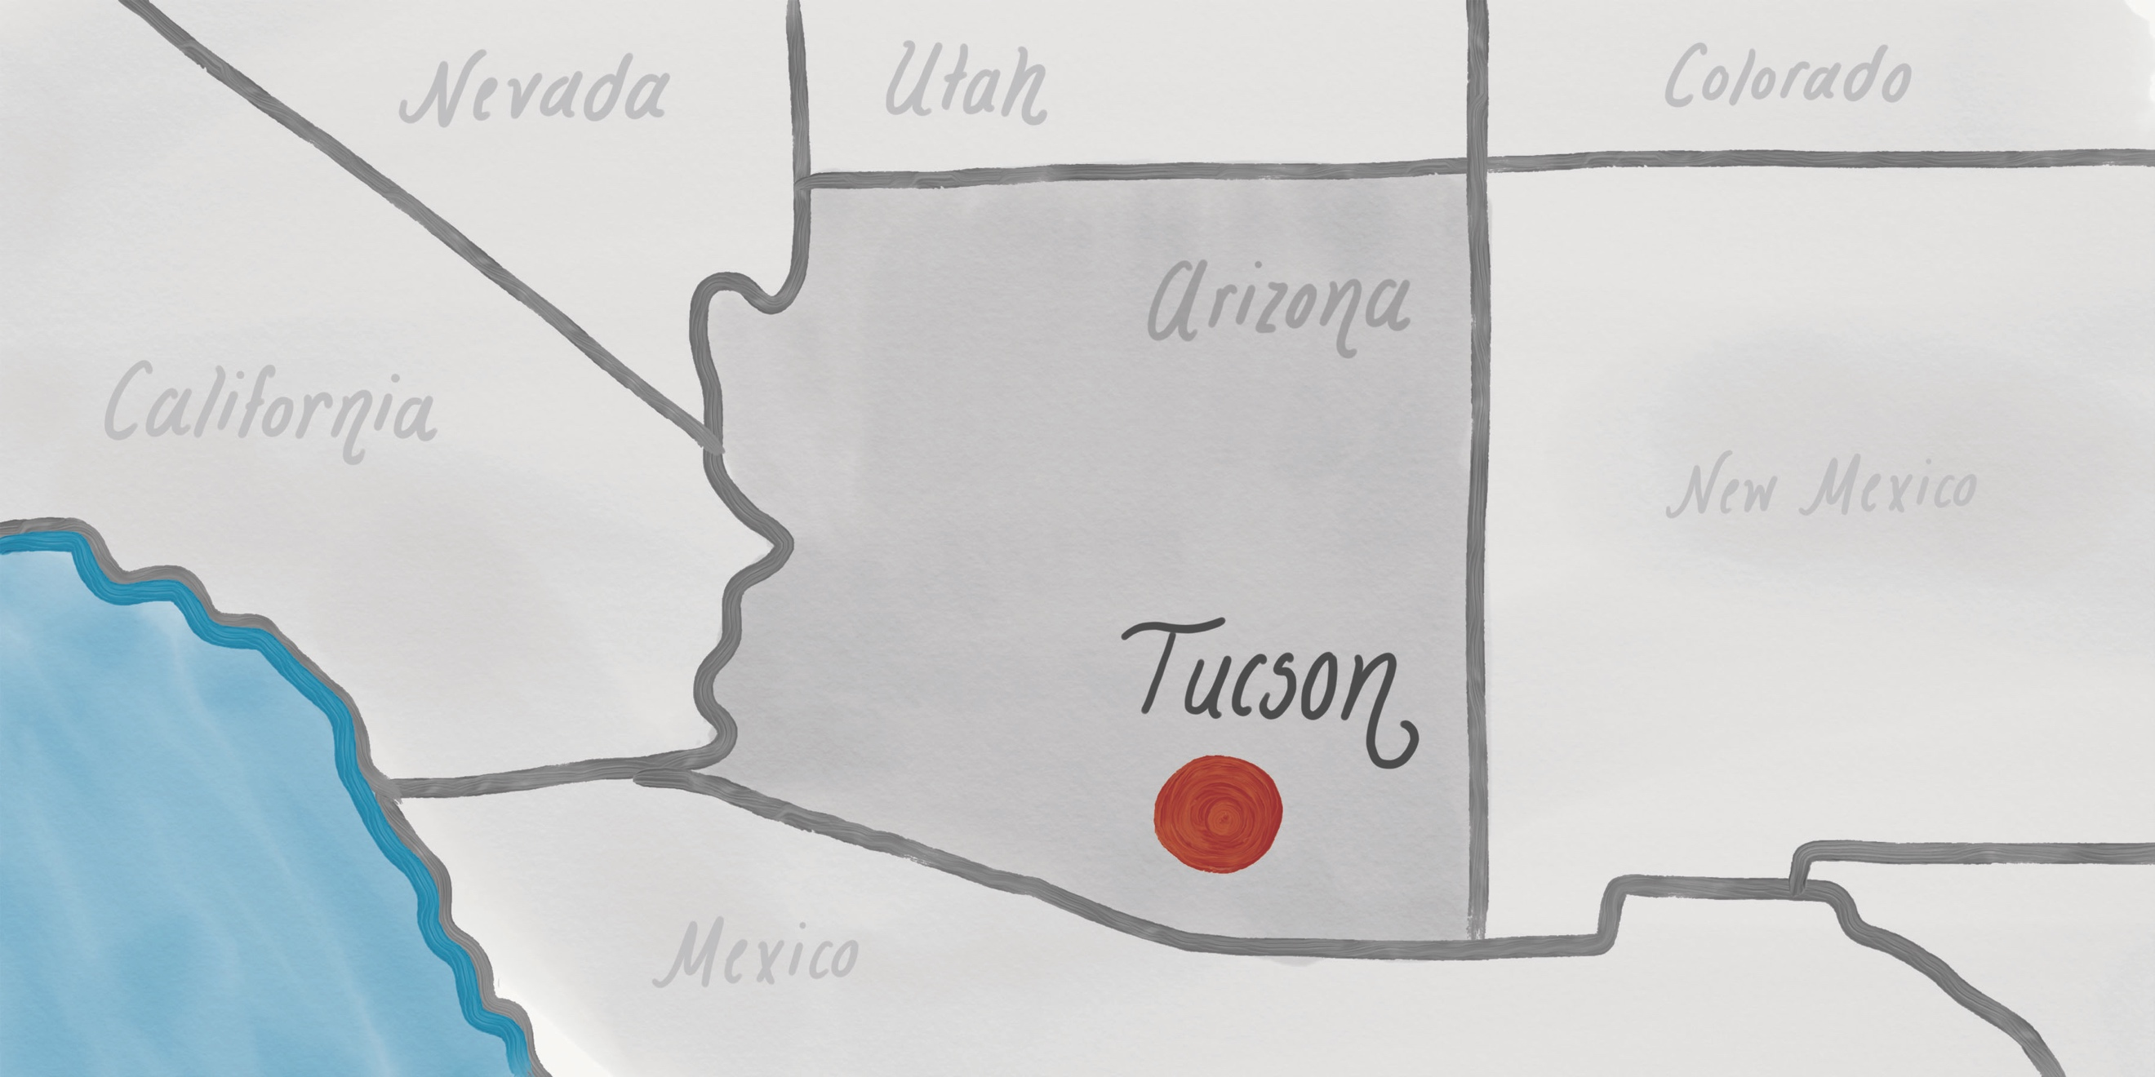
ORHON MYADAR
Associate Professor, School of Geography, Development and Environment
University of Arizona
Date: March 8, 2023, 16,00 (Wednesday, 8th week, Hillary 2023)
Venue: Dyson Perrins Building off South Parks Road OX1 3QY
See location on maps.ox

In this talk, Dr. Myadar probes a simple but important question about belonging, especially when one is violently uprooted and displaced. Based on the NITC funded research (#1377), Dr. Myadar explores contestations of belonging and exclusion to understand how different individuals have navigated, negotiated and produced social space since they were displaced from their homes and uprooted from their homelands. Accordingly, she asks: What does it mean to belong to a place, and how does our belonging inform our sense of self? What if one’s sense of place was marred with violence and tragedy? What does it mean to be “home” when one has inhabited multiple places? The theoretical concepts that she explores in seeking answers to these questions are grounded in deeply human stories as a way to contextualize abstract concepts in lived contexts. Dr. Myadar engages these abstract themes with the voices of people whose lives were violently upended by forces beyond their control to better understand the affective and lived experience of displacement and resettlement.

Organizing Department: School of Geography and the Environment
Organizer: Ariell Ahearn (School of Geography and the Environment)
Details: Desert Room (1st floor School of Geography).
Part of: SoGE Economy and Society Cluster Events

This project was funded by the National Institute for Transportation and Communities (NITC; #1377), a U.S. DOT University Transportation Center.

